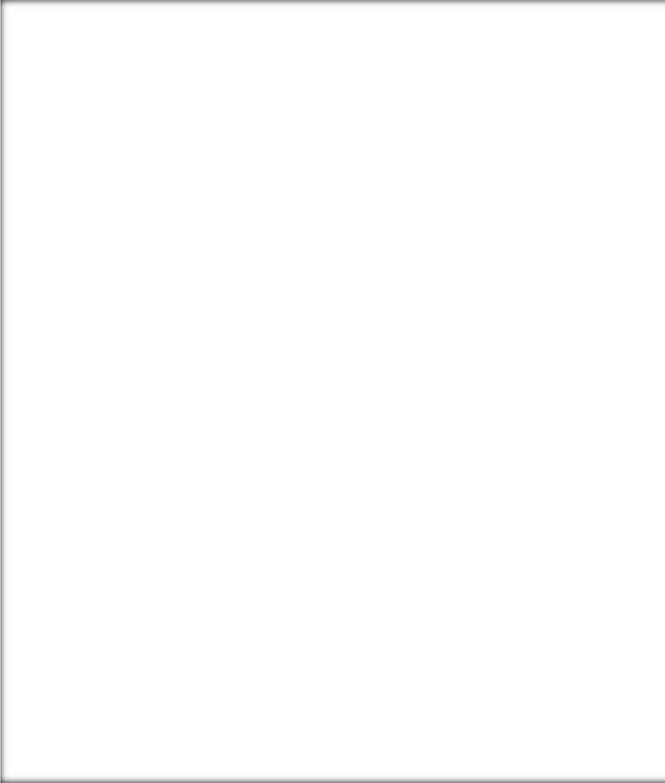

User Training Manual – Inventory Management

Prepared for

**Technica International**

Version: **4.0**

Prepared by:

Mohanad Kamal

Mahmoud Karim

Contents

1.0 Introduction 3

1.1 Purpose 3

1.2 Scope 3

2.0 Product creation 4

3.0 Inventory Processes 24

3.1 Inbound Orders 25

3.1.1 Arrival overview 25

3.1.2 Receive item from the PO directly 29

3.2 Journal Entries 32

3.2.1 Movement Journal 32

3.2.2 Adjustment Journal 34

3.2.3 Counting journal 35

3.2.4 BOM journal 38

3.2.5 Transfer journal 39

3.3 Production Process (Warehouse work for raw material picking) 41

3.4 Consume items on the project directly 44

3.5 Counting by the warehouse management mobile application 46

4.0 Master Planning 49

5.0 Reserved and unreserved item check 51

6.0 Inventory Reports 53

6.1 On-hand list 53

6.2 Inventory transactions 54

6.3 Critical on-hand inventory 55

6.4 Inventory value report 55

|  |
| --- |
| INTRODUCTION |

# 1.0 Introduction

## 1.1 Purpose

The purpose of this document is to provide users with clear and practical guidance on how to manage inventory within Microsoft Dynamics 365 Finance and Operations. It explains the key processes and functionalities used to control, track, and maintain inventory, ensuring accurate stock levels, efficient operations, and reliable reporting for business decision-making.

By the end of this training, users will have a solid understanding of Inventory Management Module.

## 1.2 Scope

This training manual covers the essential features and processes of the Inventory Management module in Microsoft Dynamics 365 Finance and Operations. The content focuses on day-to-day activities such as item setup, inventory transactions, stock adjustments, transfers, and reporting. The scope is limited to standard inventory operations.

# 2.0 Product creation

Creating products D365 F&O is essential for establishing a centralized, unified system for inventory management, procurement, production, projects, sales, and financial tracking across different legal entities

1. Navigate *Product Information Management > Products > Released products*

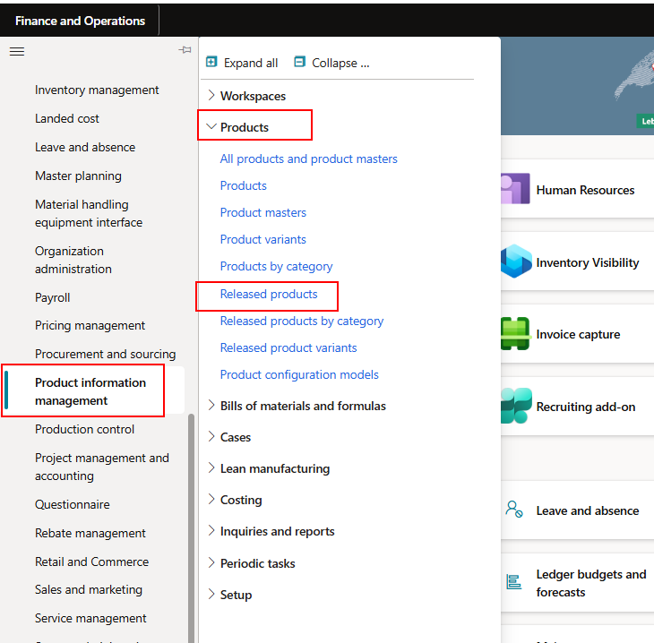

1. Click on New

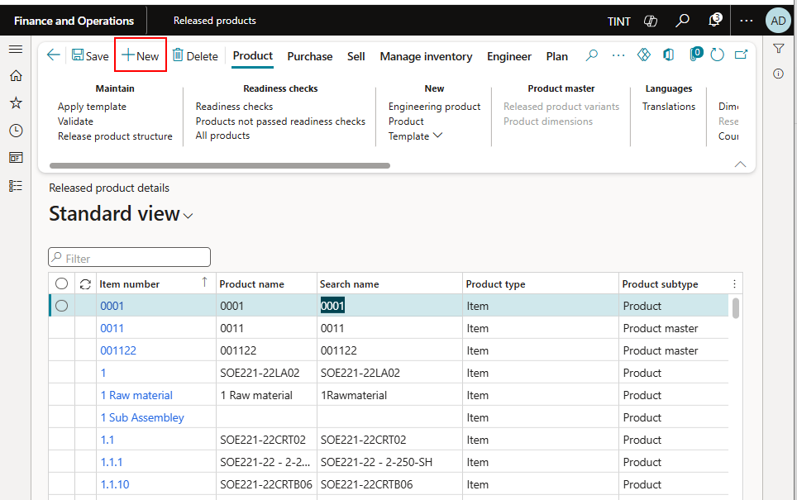

1. Enter the following information

Product type: Item

Product subtype = Product

Product number

Product name

Select an item model group (Weighted average)

Item groups as per the below list:

|  |  |
| --- | --- |
| **Items Code** | **Items Group** |
| CRM | Component & RM |
| SFP | Semi-finished product |
| FIP | Finished Product |
| FAC | Factory Consumables |
| OEM | OEM Equipment |
| INS | Installation |
| PAF | Packing & Freight |
| SER | Services |
| DIG | Digital Services |
| SUB | Subcontracting |

Storage dimension group: Select SiteWHLoc

Specify a reservation hierarchy (Standard)

Specify the unit sequence group ID as the inventory unit

Tracking dimension group: None; Serial might be used in a later stage

Specify inventory unit, purchase unit, sales unit, and BOM unit

Specify the item sales tax group

If there is a specified vendor, specify a vendor

Specify the vendor item number

Specify the purchase price, sales price, inventory price if known.

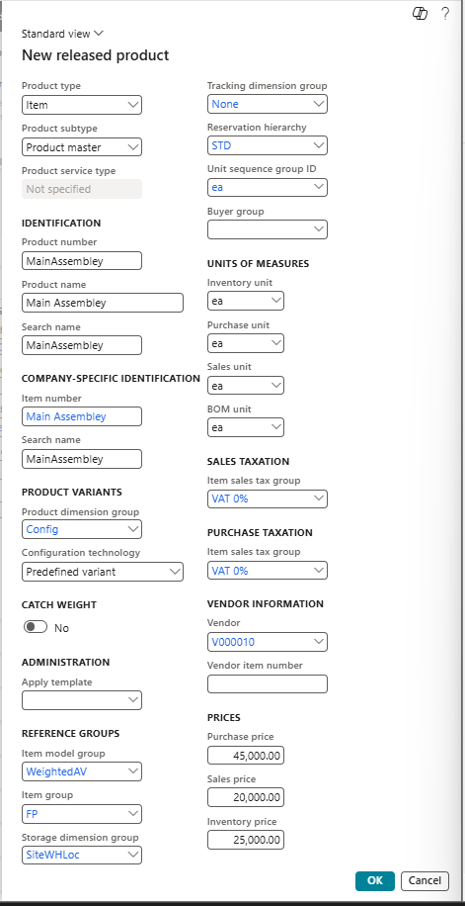

1. Press OK
2. An item record is created

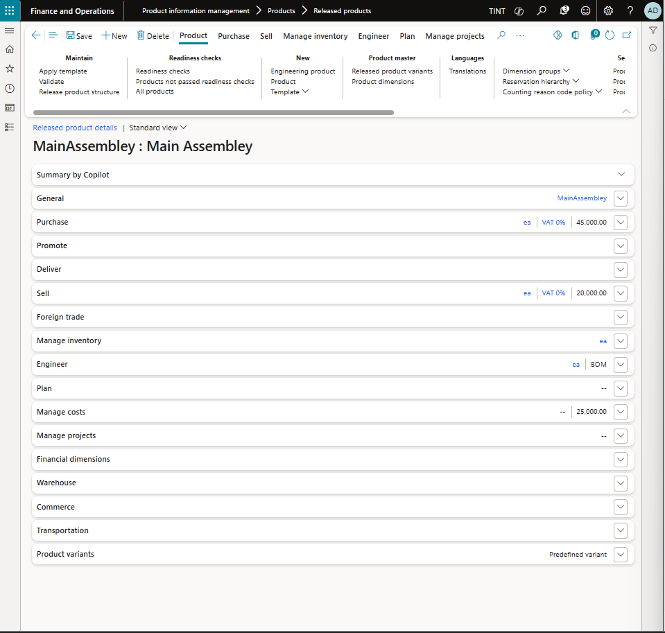

1. Under General, specify a description
   1. Select product number

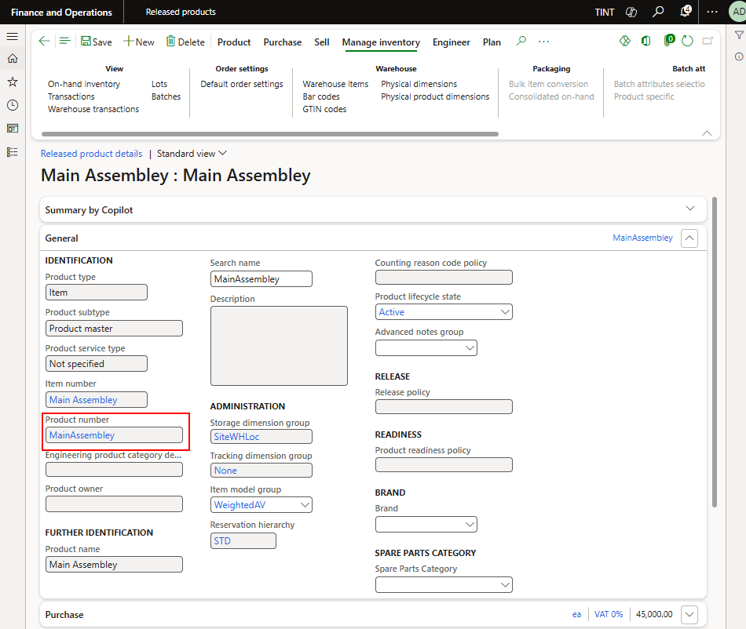

* 1. Enter description

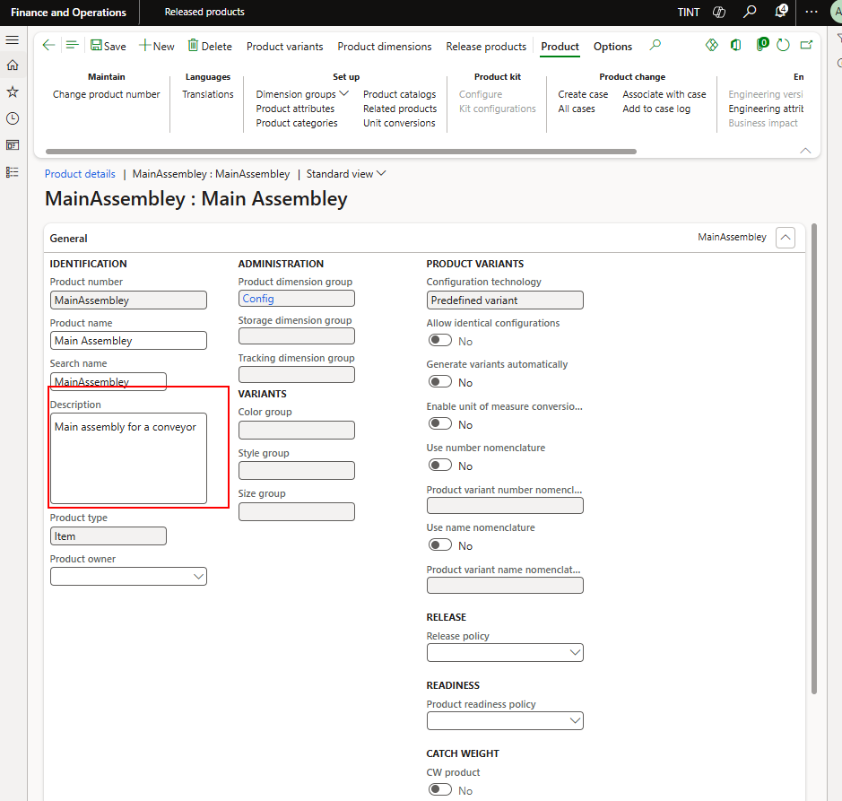

* 1. Go back to the Released product
  2. Refresh

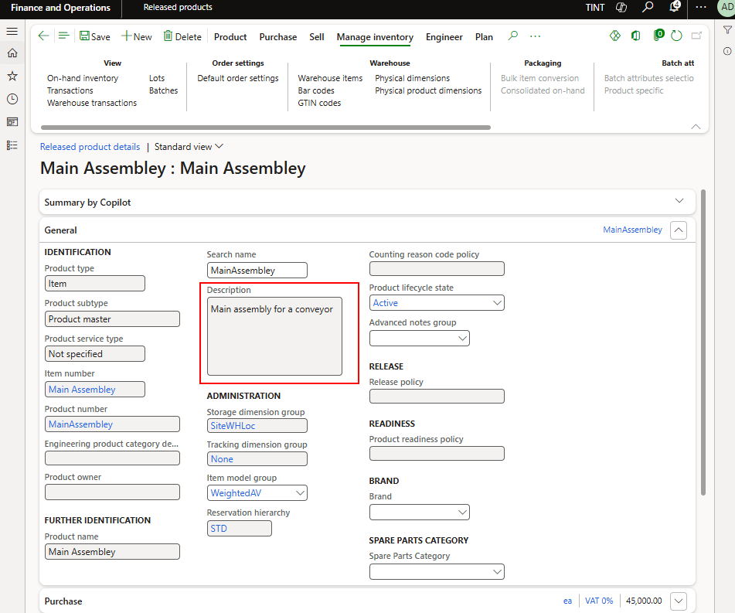

1. Specify the brand

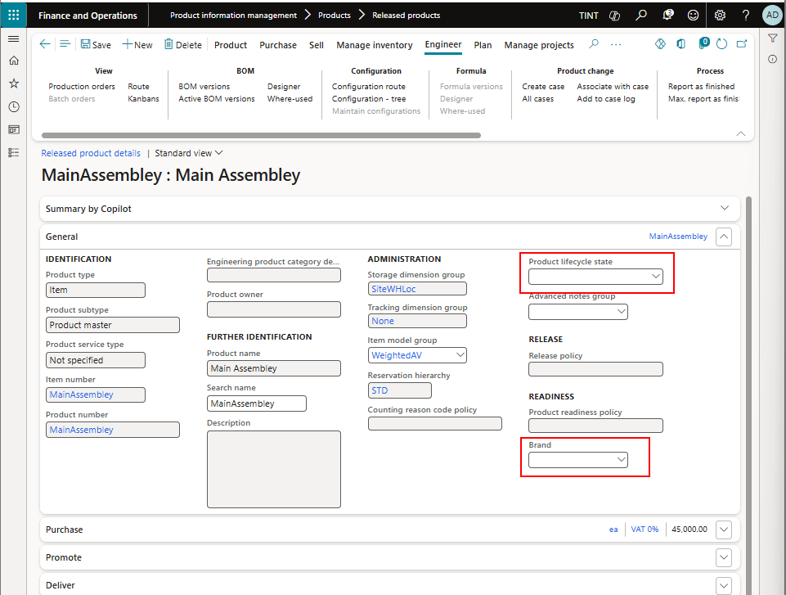

1. Under manage projects, specify a project category for the item:
   1. Projitem for assembly or subassembly
   2. Purchased for the purchased components
   3. Raw material in case of raw material creation.

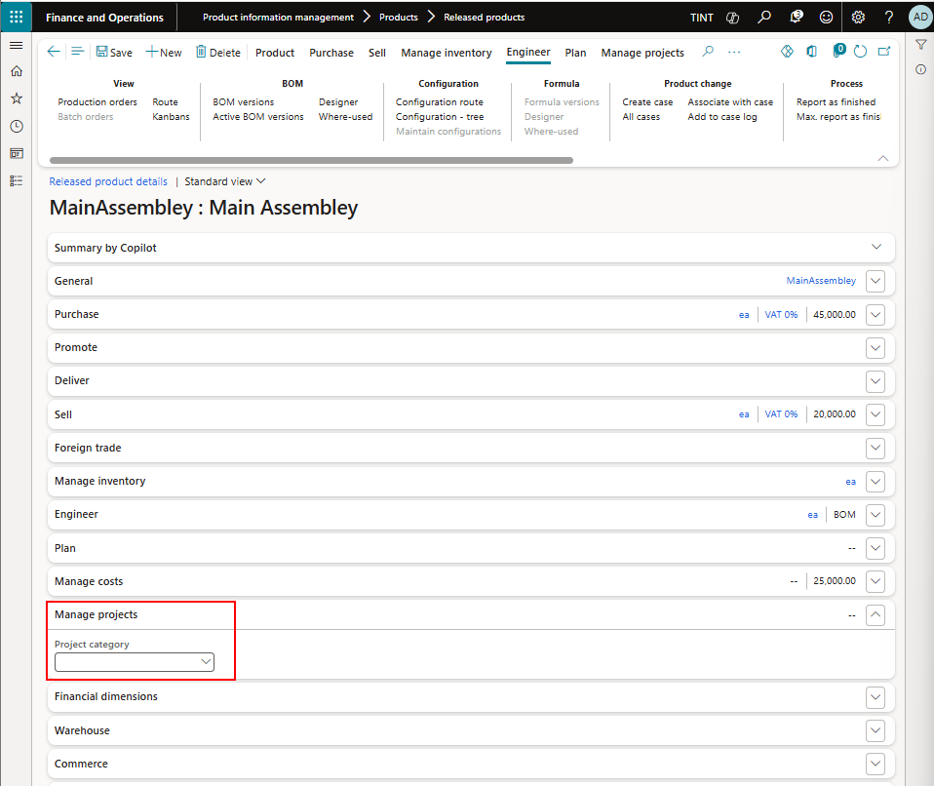

1. Under Plan, specify a coverage group for the item. The coverage group is used by the system to calculate the need for the item based on demand. It should be **Require** to create a planned order for each requirement needed or it should be **minimum/maximum** in case a replenishment for stock is needed.

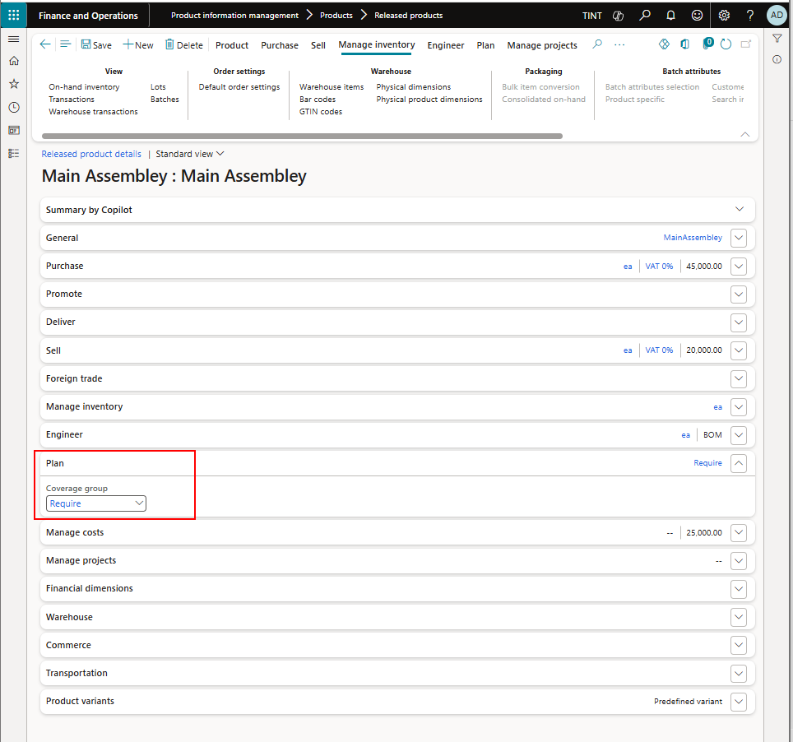

To specify the min/max for the item. Under Plan > Coverage> item coverage

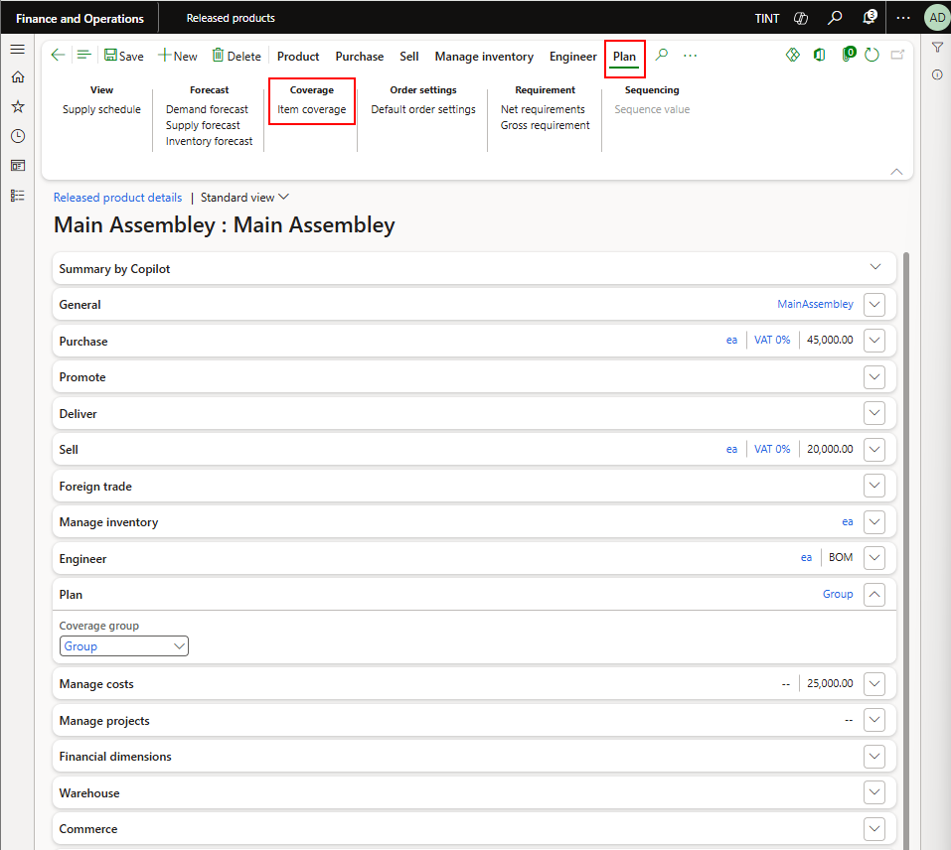

Add New line

Specify site, configuration, warehouse, minimum and maximum

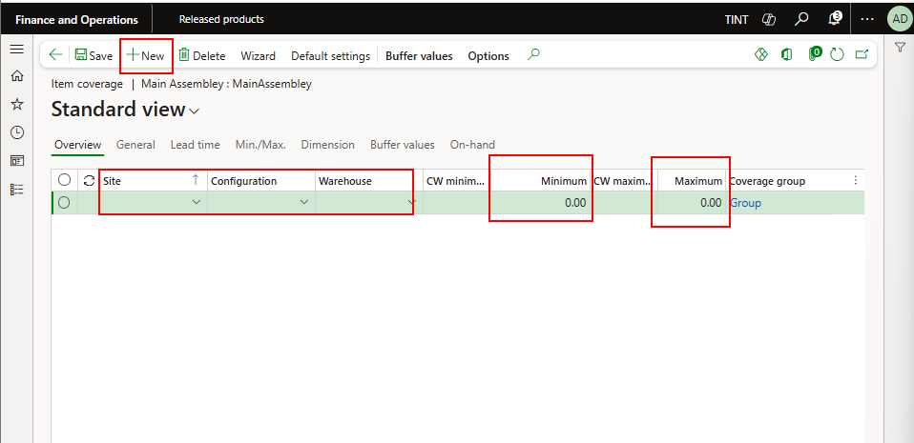

1. Go back
2. Under manage costs > costing. Specify a cost group

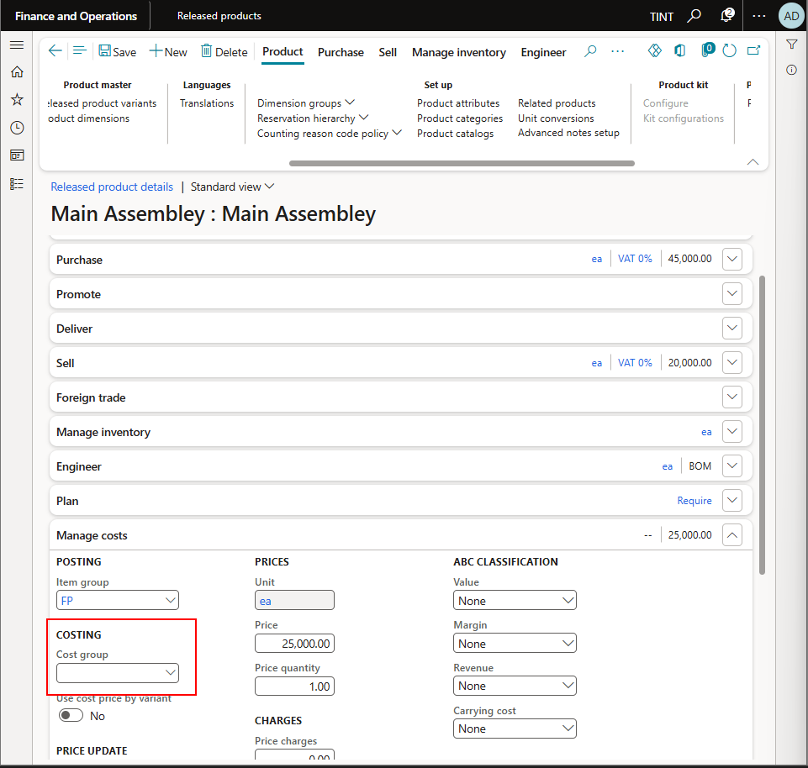

1. The costing group should reflect the same type chosen as project category.

ProjItem > Final Product

Purchased Component > Purchased components

DM for Raw material

1. Under Product > Setup > Product categories. Specify the procurement categories for the item

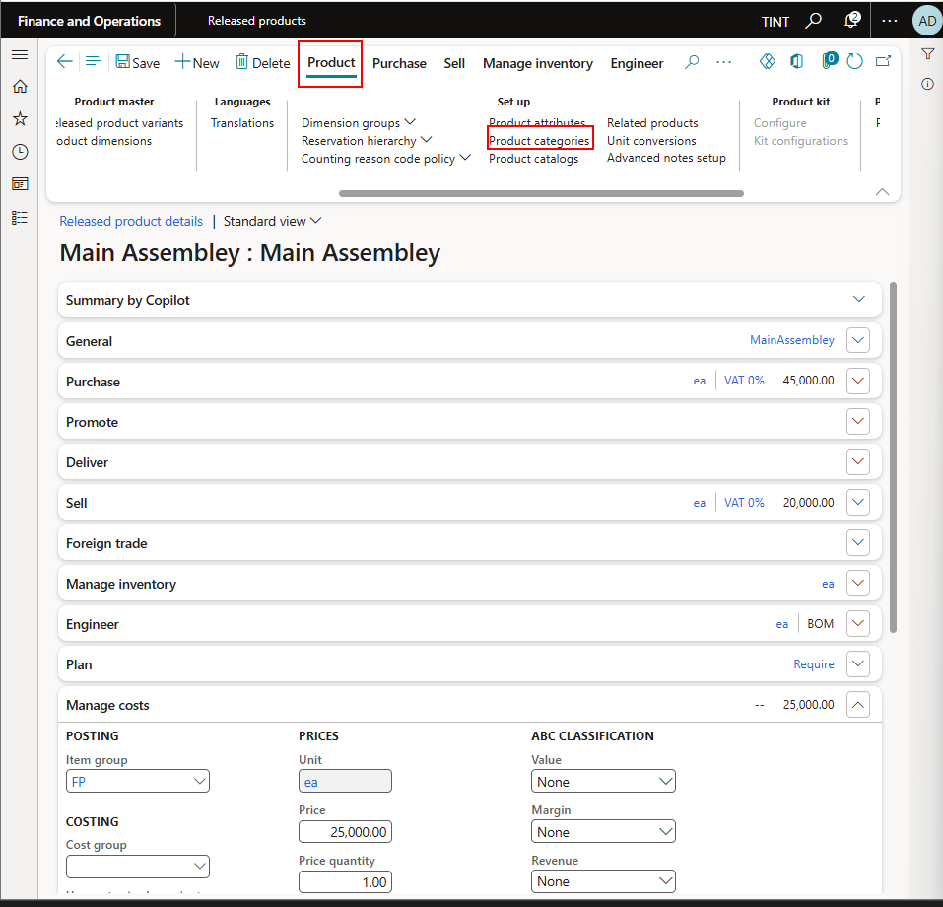

1. Attributes
   1. Under Product > Setup > product attributes. Specify the attributes for the item

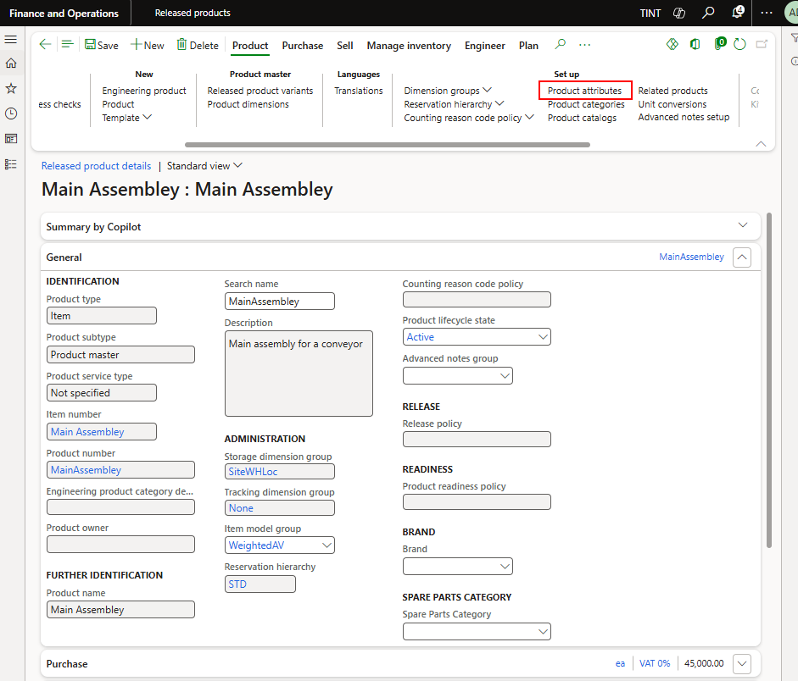

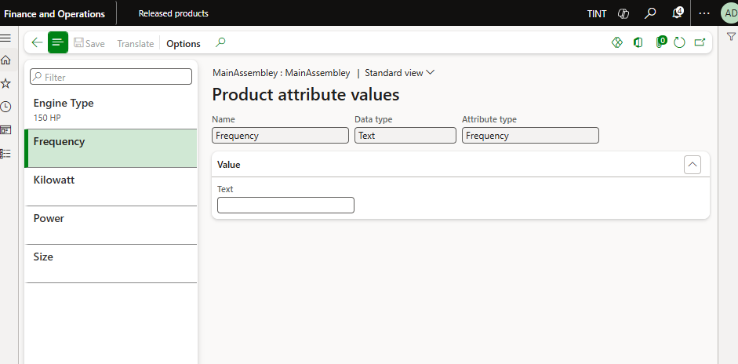

* 1. Create new attribute record
     1. Under product information management > setup > categories and attributes > attributes
     2. Click New

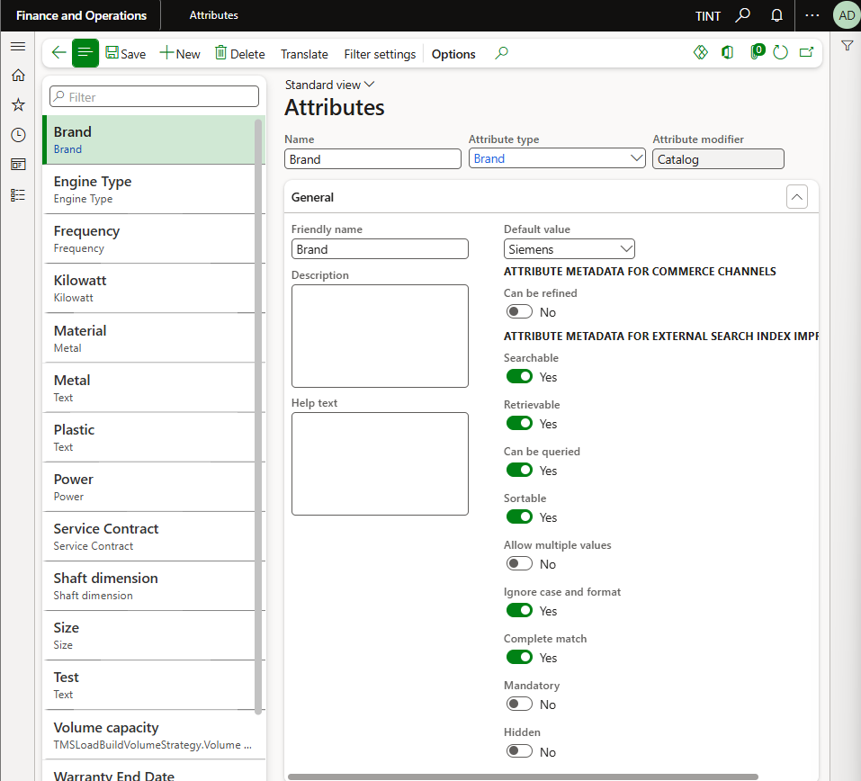

* + 1. Specify the name, attribute type, enter a description if applicable.

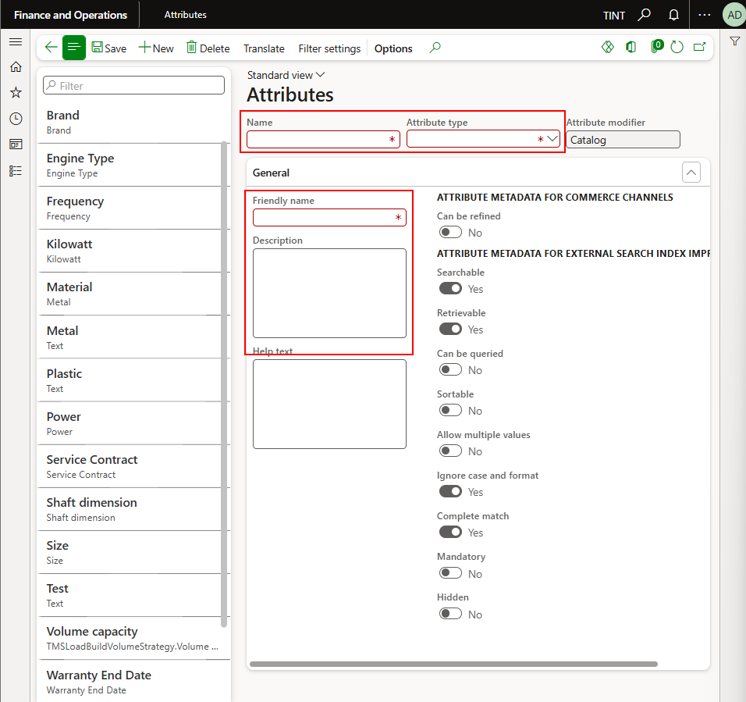

* + 1. Link the attribute to the procurement category

Procurement and sourcing > procurement categories.

Select a procurement category.

Under production attribute

Click New and add the attributes that you want

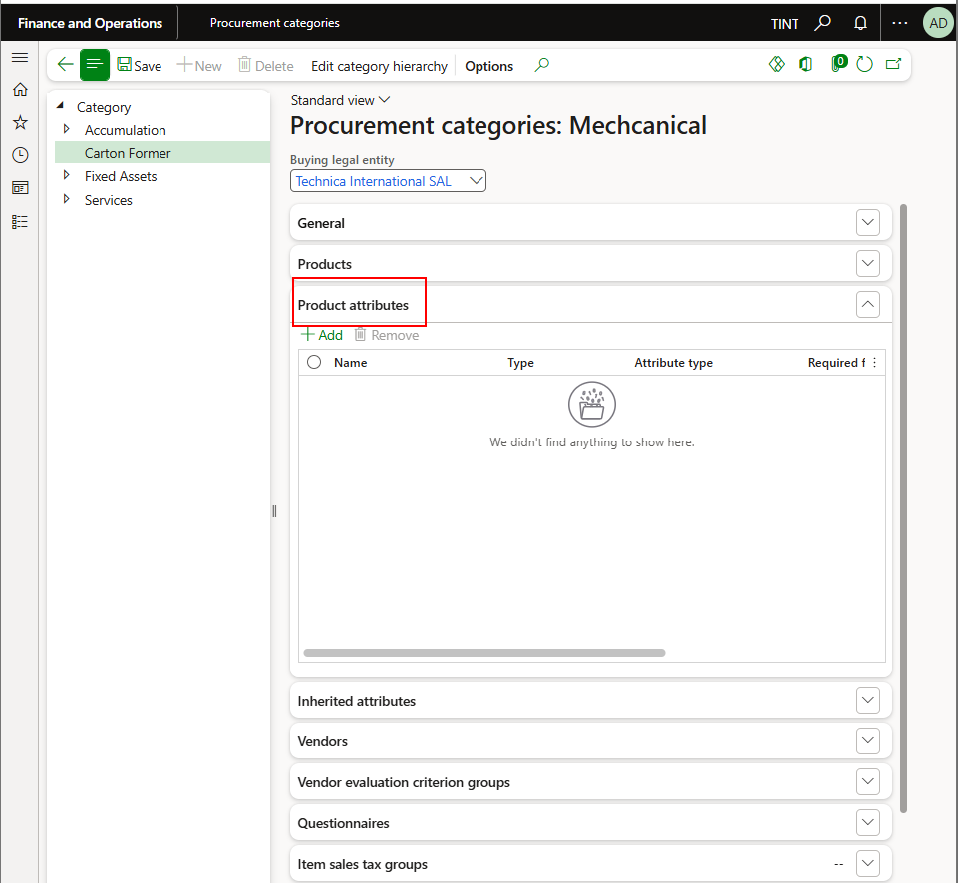

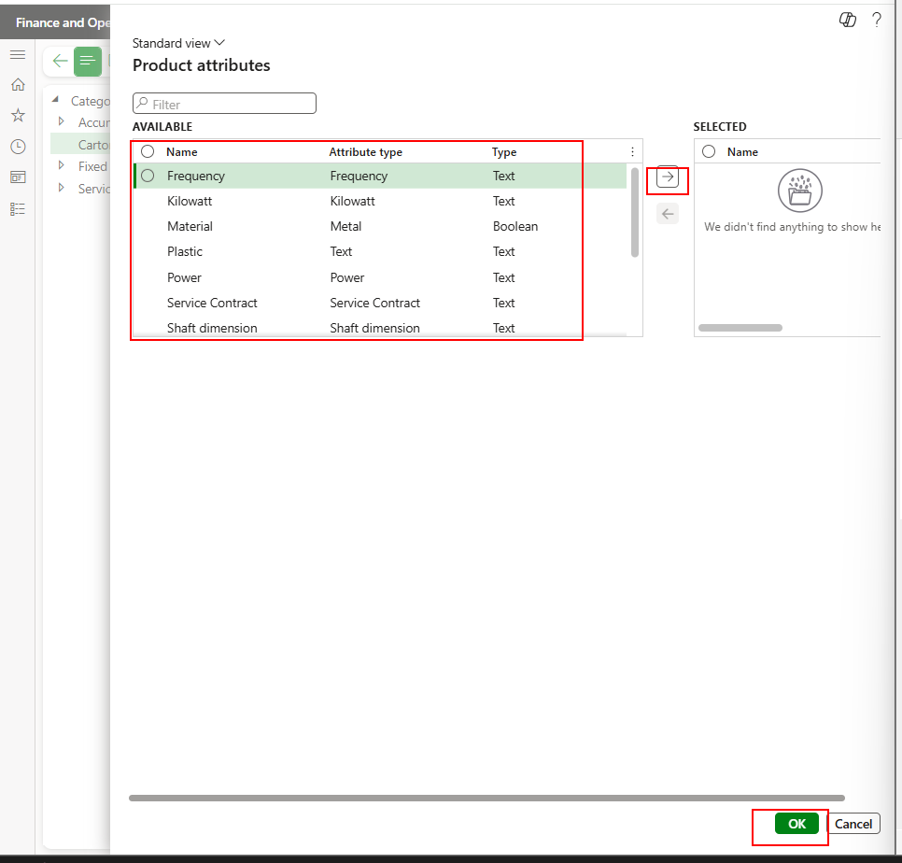

* + 1. When linking the item to the procurement category, the attributes added to the procurement category will show the level of the item.

1. Select a category hierarchy and a category

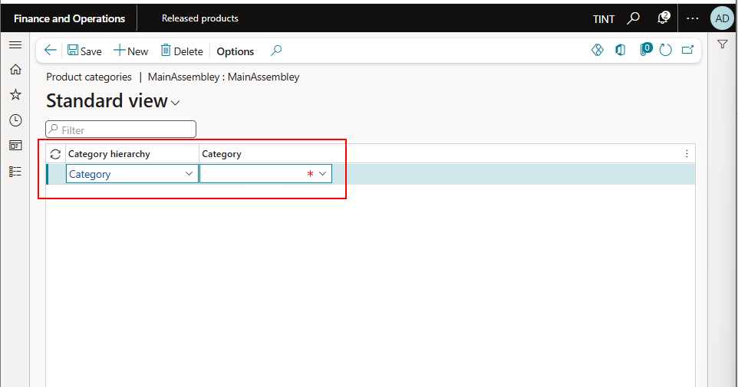

1. Go back to the Released product
2. Under Product > Product Master > Product dimension, specify the configuration

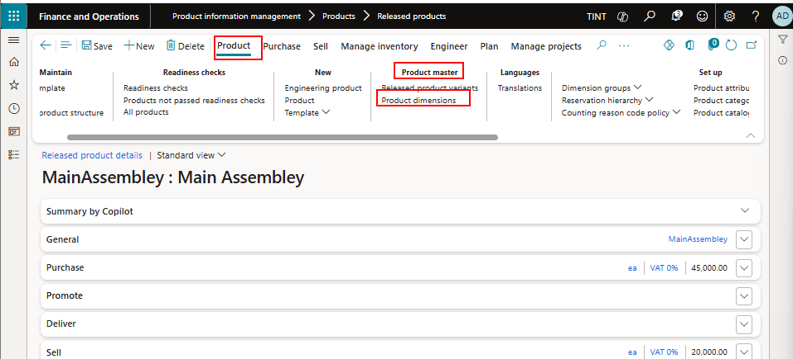

Click New and add a configuration

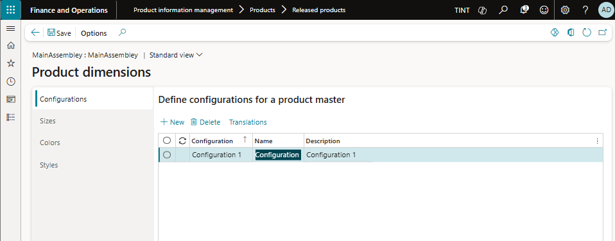

1. Go Back to the Released product
2. Under product > product master > Released product variants, Add new and fill the product name and configuration.

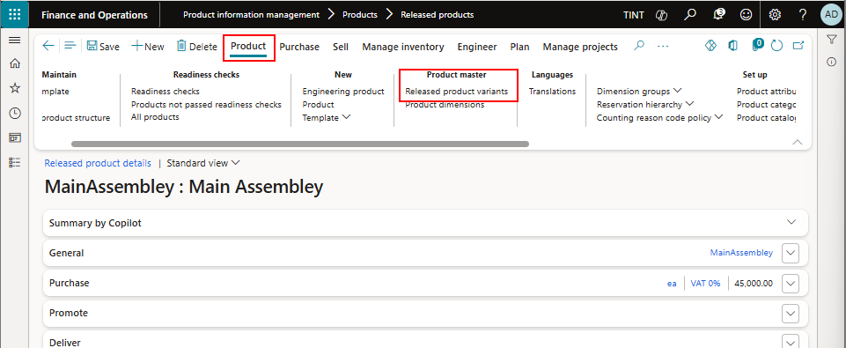

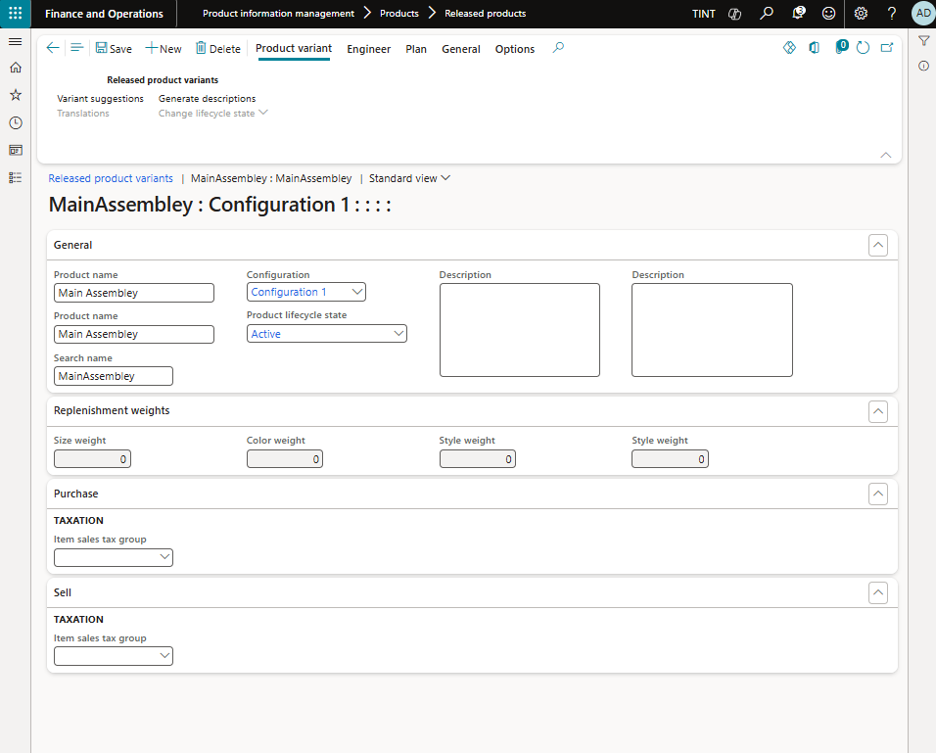

1. Go back to the Released product
2. Under Manage inventory > Order settings > Default order settings. Specify if the item is purchased or produced and specify the default site and warehouse for purchase, sales, and inventory orders. The default site is Lebanon and the default warehouse is Main.

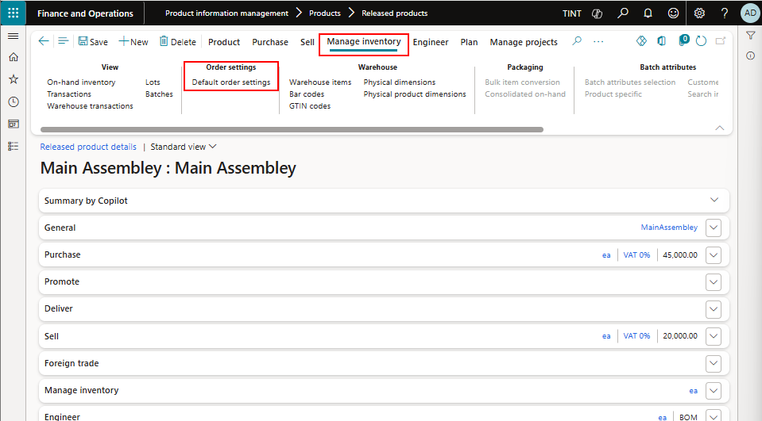

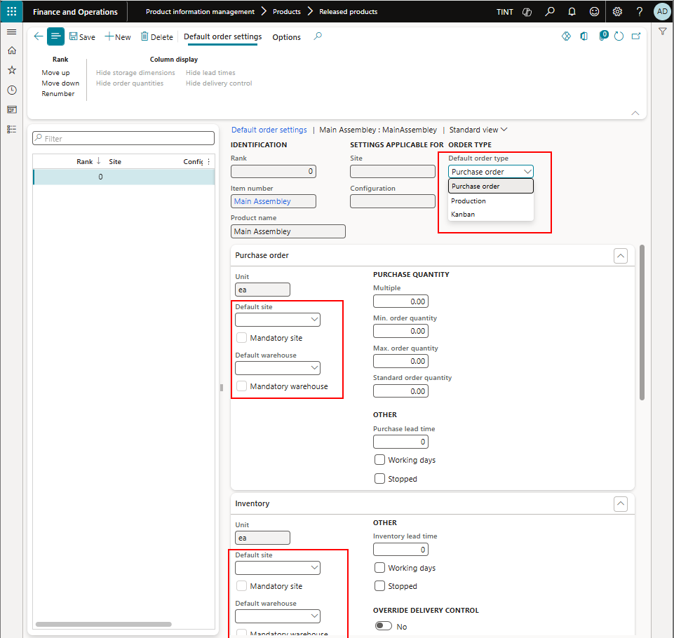

# Inventory Processes

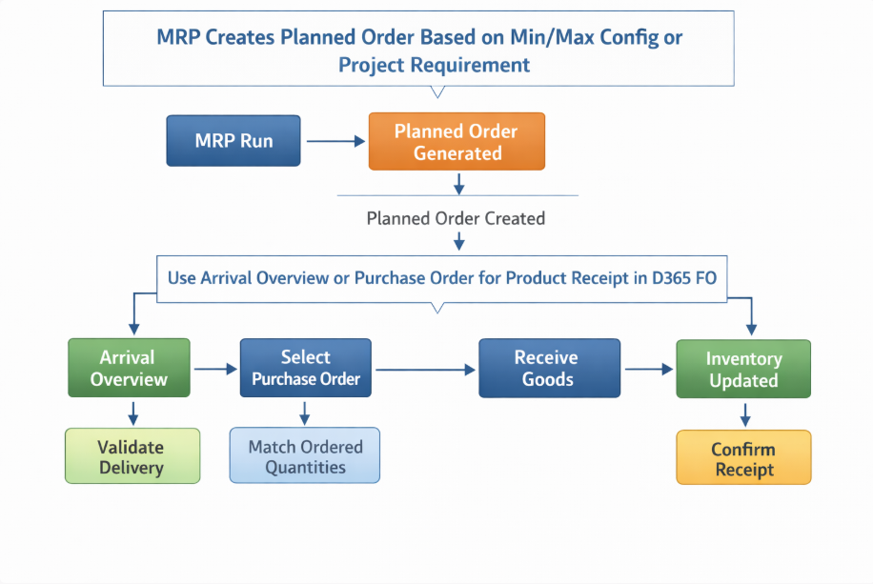

## Inbound Orders

We can receive items in stock in 2 ways in the system.

* Arrival overview when we don’t have the information on the received items or POs expected to be received
* Directly on purchase order whenever the purchase order of the received items is known.

### 3.1.1 Arrival overview

* **The Arrival overview page** provides an overview of all expected incoming items.

It also shows arrivals that you can initialize based on the overview. You can view a list of orders that are expected to be received. The overview is divided into a header and lines. The header information is grouped by the order type, expected receipt date, and delivery destination. When you select a header line for arrival, all the detail lines that are related to the receipt reference are selected for arrival in the line details part of the page. You can also filter by specific warehouse, item number, mode of delivery, days back and days forward.

1. Inventorymanagement > Inbound orders > Arrival overview

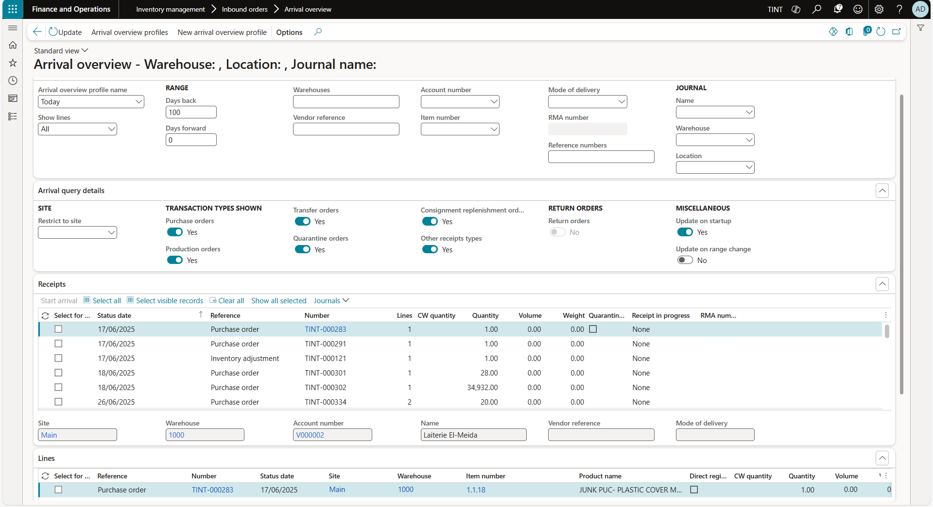

1. It is possible to filter by days. By default, the purchase orders that show under receipt are the purchase orders expected to be received on the same day. To view a list of purchase orders expected to be received a certain number of days before today or/and certain number of days after today. Enter a number in the days back, days forward fields.

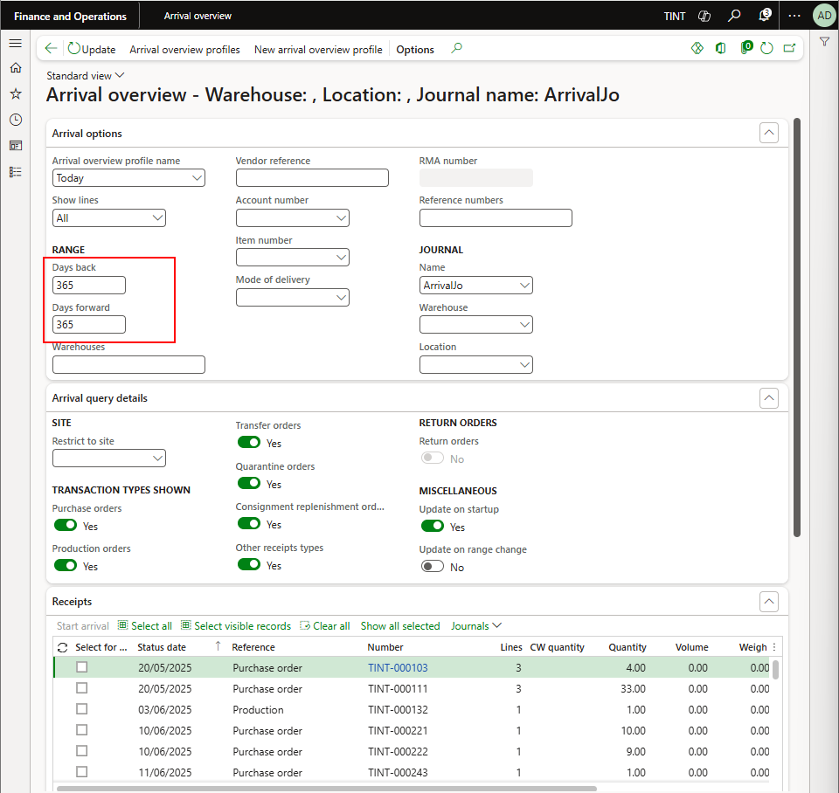

1. Selectthe purchase order that you want to receive and specify the lines of the purchase order.

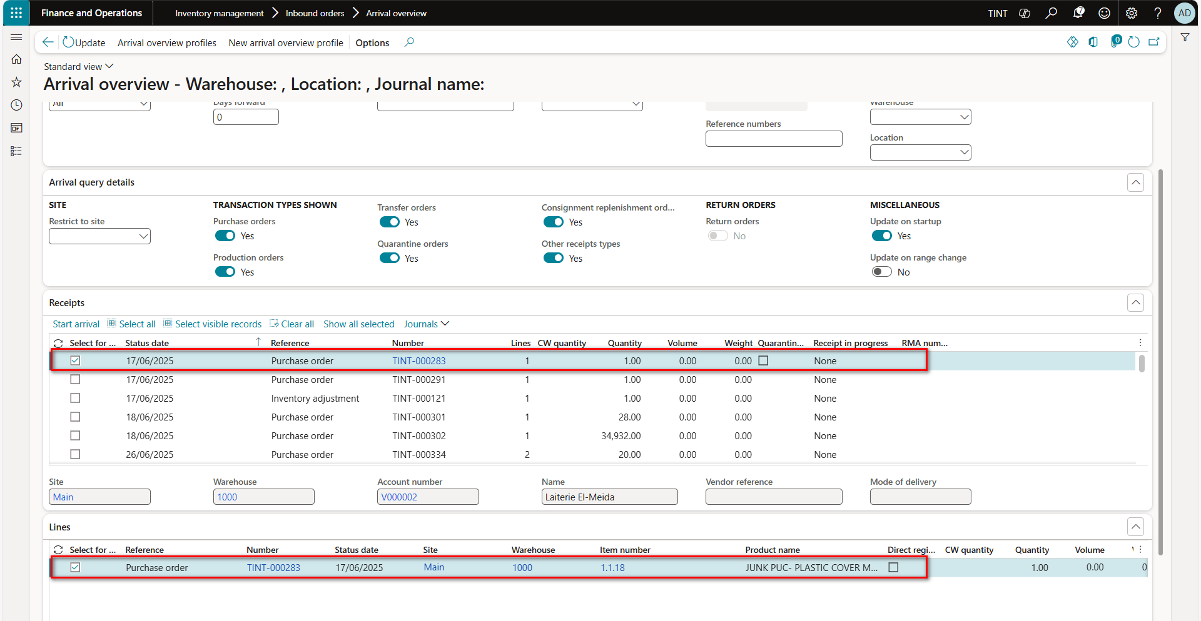

1. Click on start arrival.

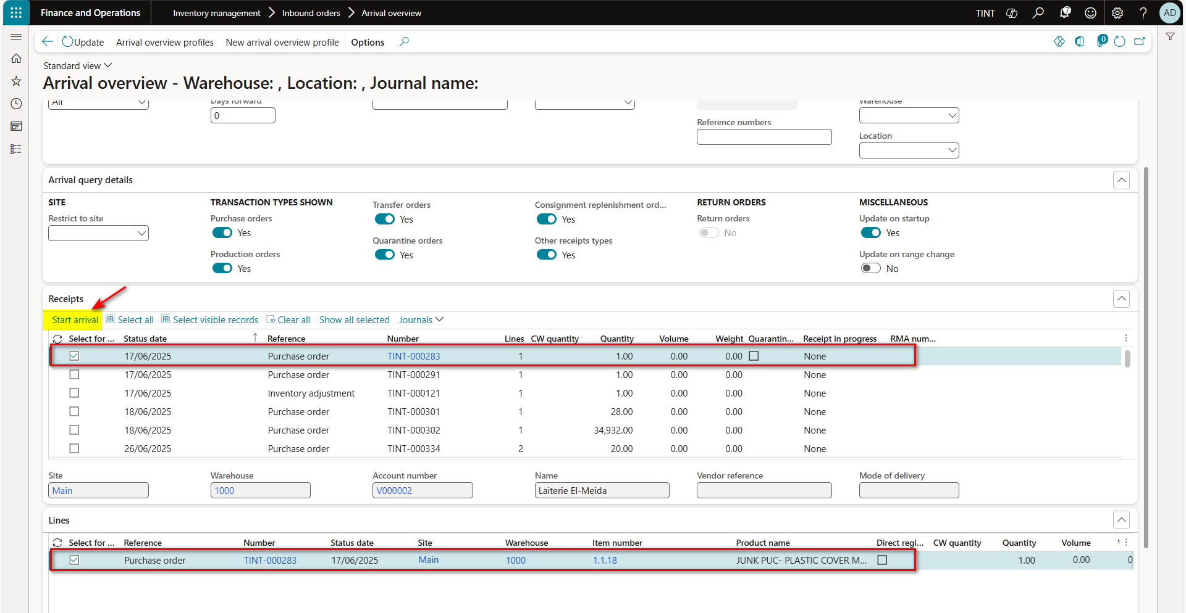

1. The system will create item arrival journal to register the receiving of the items.

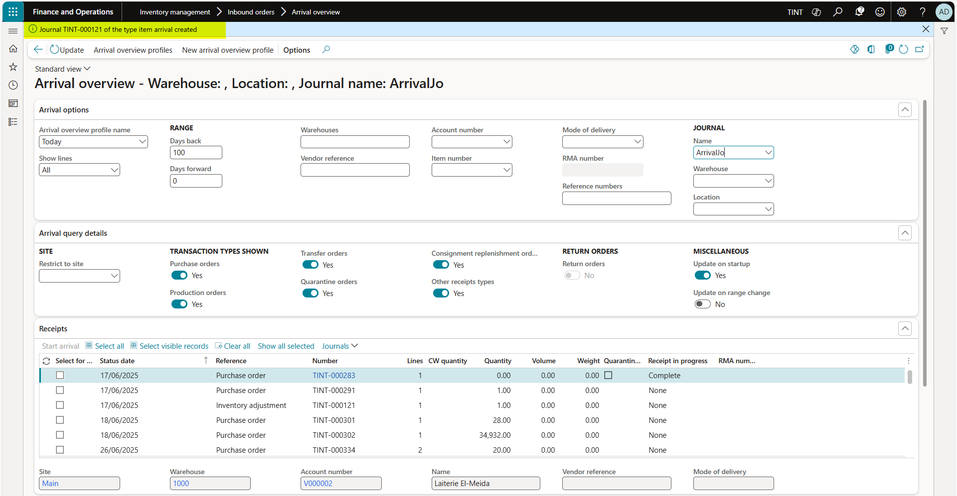

1. Navigate to item arrival journal screen then post the journal, Inventory management > Journal entries > Item arrival > Item arrival.

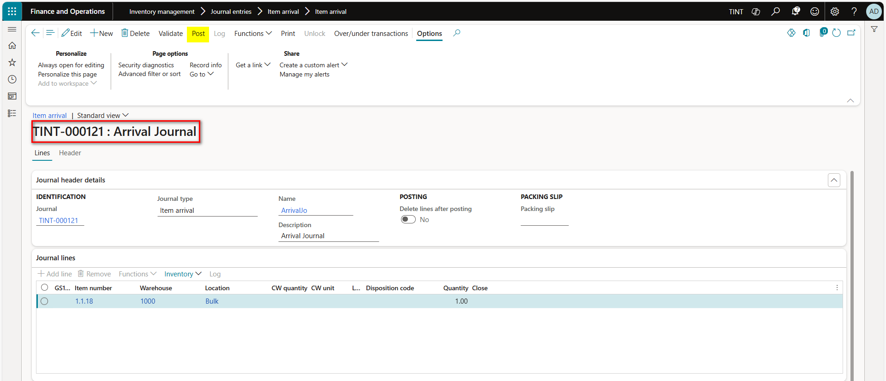

1. From functions > Product receipt, to start the receiving.

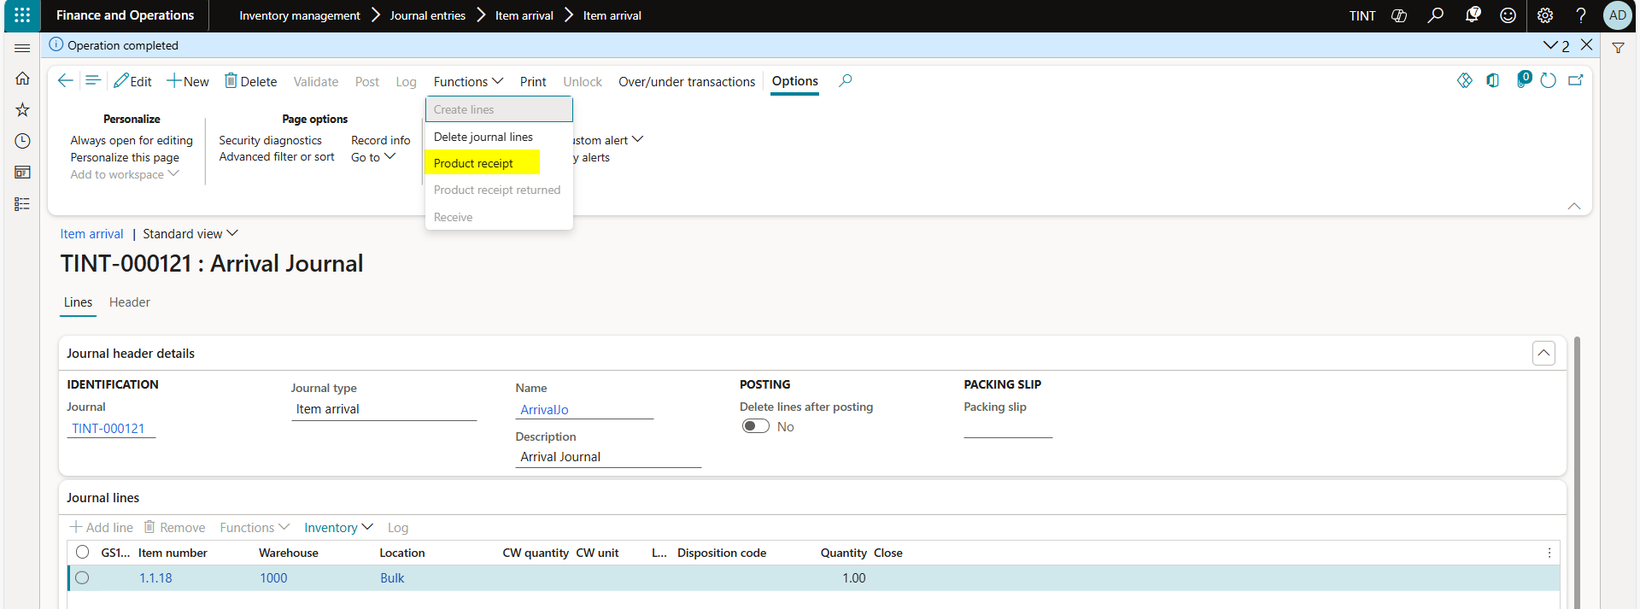

1. Enter the number of product receipt, then post the product receipt.

### 3.1.2 Receive item from the PO directly

Another option to receive items in stock is on PO level directly instead of using the arrival view when the purchase order is known

Procurement and sourcing > purchase orders > all purchase orders

1. The list of all purchase orders will show
2. Select a purchase order with approval status confirmed and status = Open order as seen in the screenshot below. Open order means that the purchase order is not yet fully received.

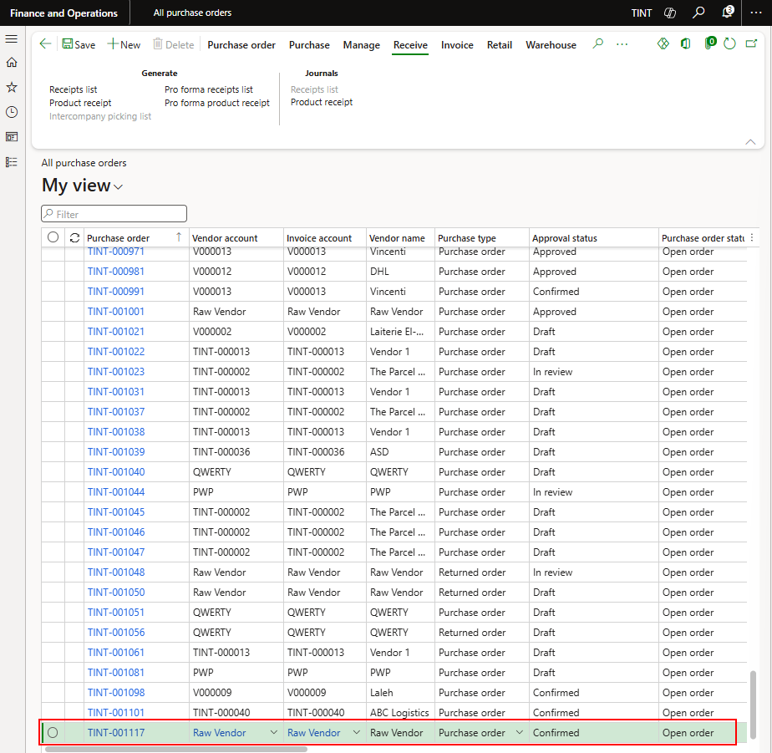

1. Under receive > generate > select product receipt

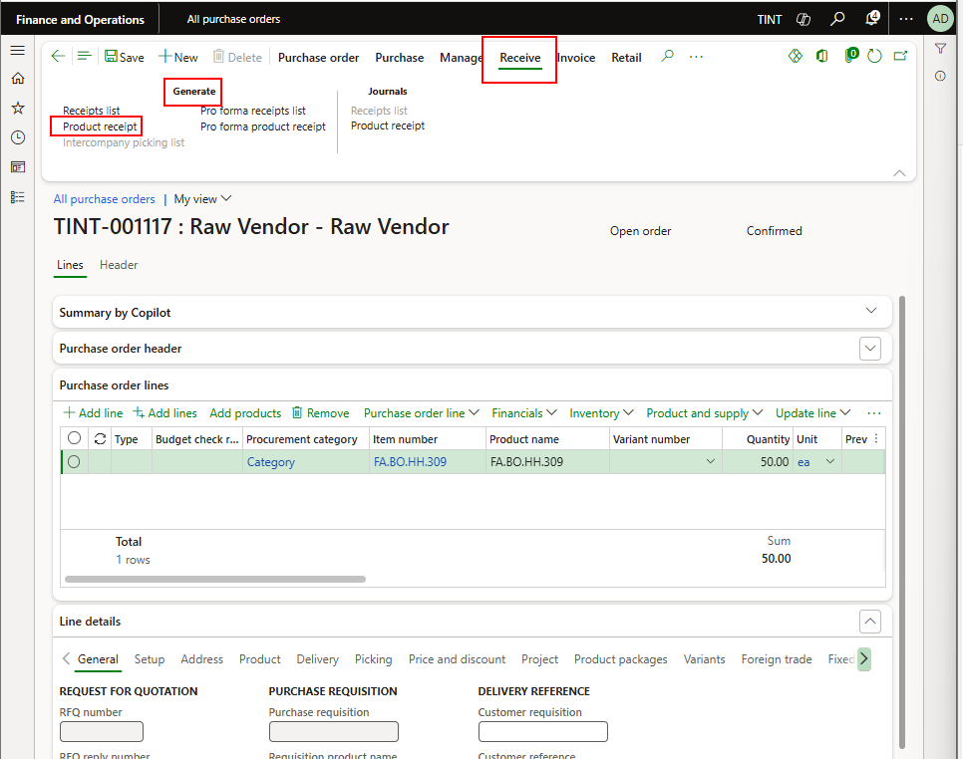

1. The dialogue for product receipt will open. Specify the product receipt number, which will be the supplier packing slip number/ delivery note number or if not present the purchase order number, quantity received and tick the checkbox close for receipt on line level in case you are not expecting the rest of the quantity for that item.

- 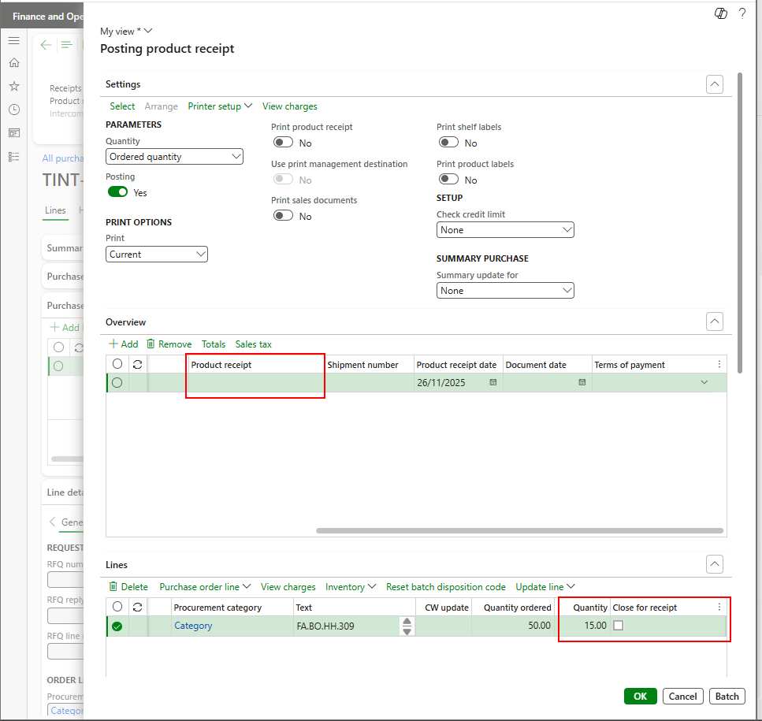

1. Press Ok to post product receipt

## Journal Entries

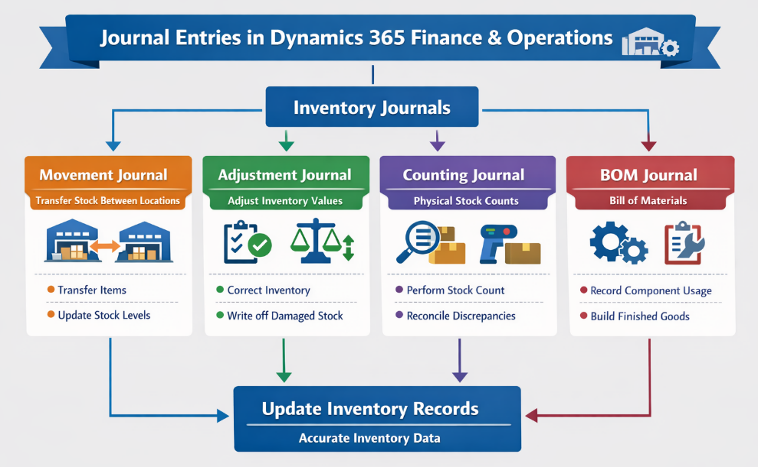

### Movement Journal

An inventory movement journal is used to adjust inventory levels while specifically defining an offset ledger account for every transaction, allowing for precise financial tracking of cost. **It is essential for manually decreasing stock with specific cost impacts** without using standard Purchase or Sales orders.

* **When you use an inventory movement journal**, you can add cost to an item when you add inventory, but you must manually allocate the extra cost to a particular general ledger account by specifying a general ledger offset account when you create the journal. The inventory movement journal type is useful if you want to overwrite the default posting accounts.

1. Navigate to Inventory management > Journal entries > Movement

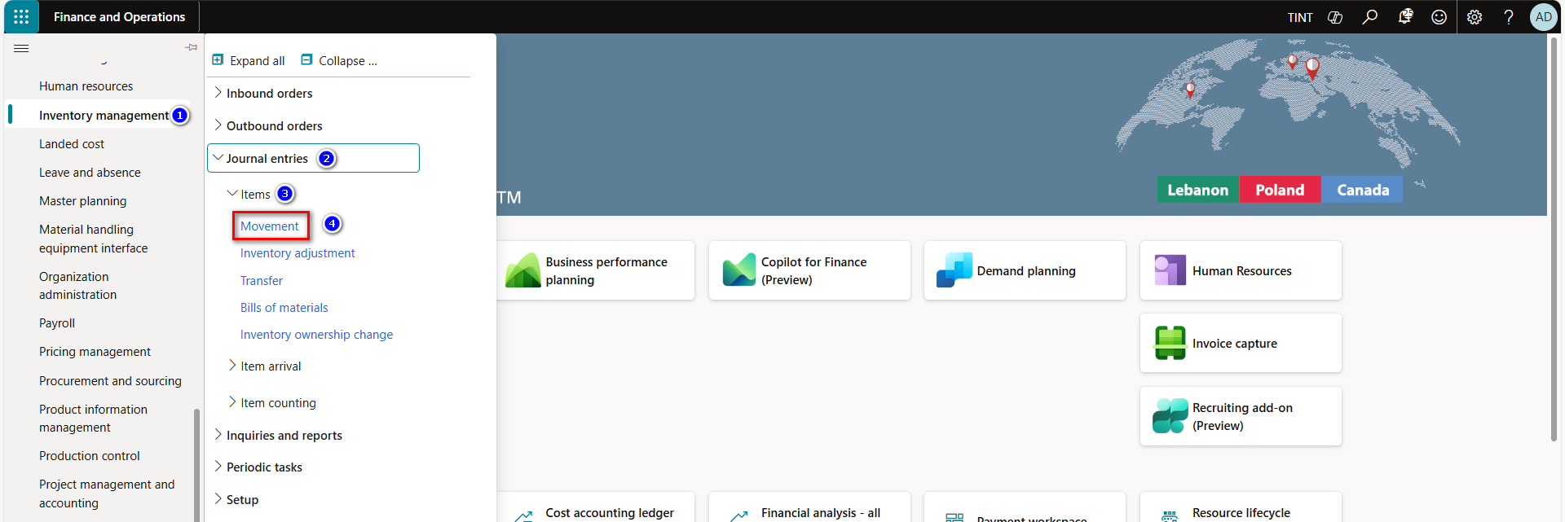

1. Click New, to create new journal.

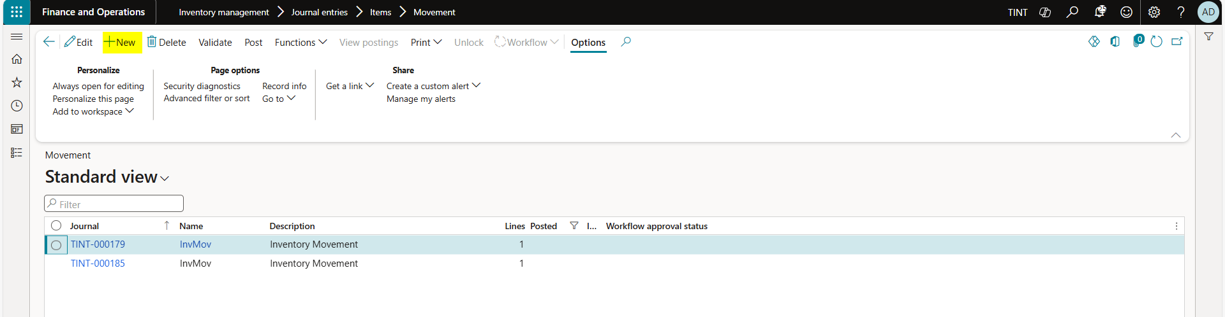

1. In the journal lines Fast tab, click New to create a new journal line.

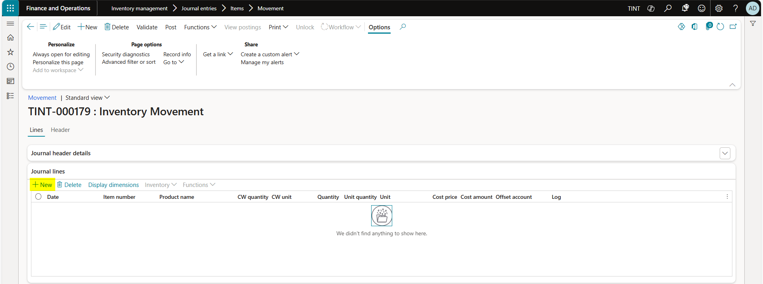

1. In the Item number field, select the item number.
2. In the Warehouse field, select the warehouse.
3. In the Quantity field, enter the quantity.
4. In the Cost price field, enter the cost price for the item.
5. In the Offset account field, select the ledger offset account to be used in connection with inventory movements.
6. Click on Post, to post the journal

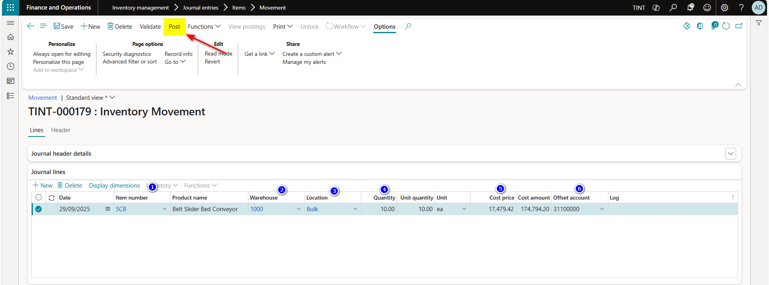

### Adjustment Journal

An inventory adjustment journal is used to reconcile discrepancies between physical stock and system records, enabling quick, manual, and direct updates to inventory quantities and costs.

* **When you use an inventory adjustment journal,** you can add cost to an item when you add inventory. The extra cost is automatically posted to a specific general ledger account, based on the setup of the item group posting profile. Use this inventory journal type to update gains and losses to inventory quantities when the item should keep its default general ledger offset account.

1. Navigate to Inventory management > Journal entries > Inventory Adjustment

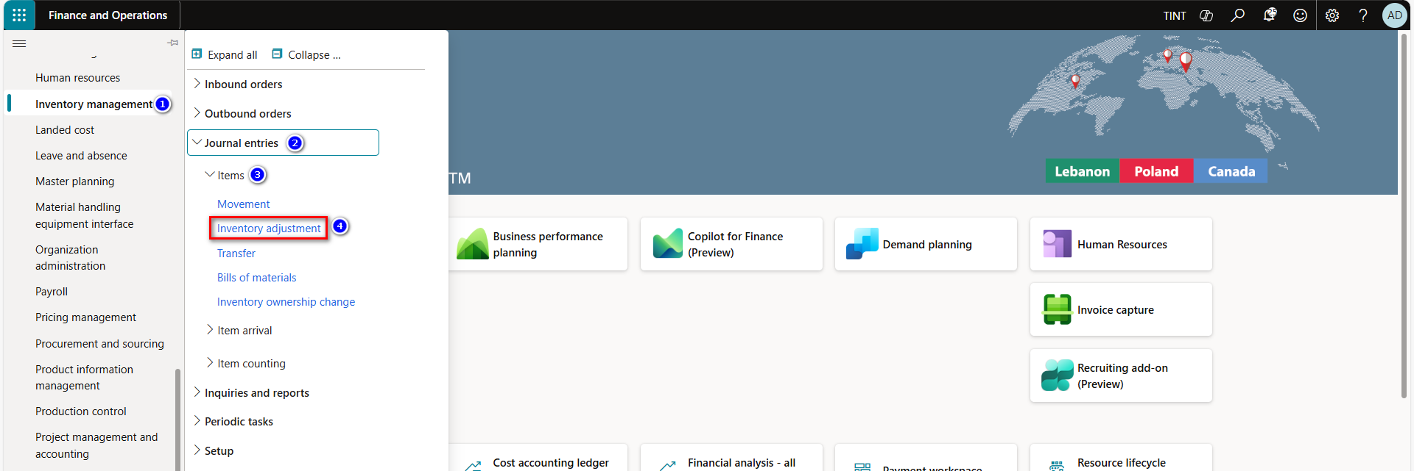

1. Click New, to create new journal.

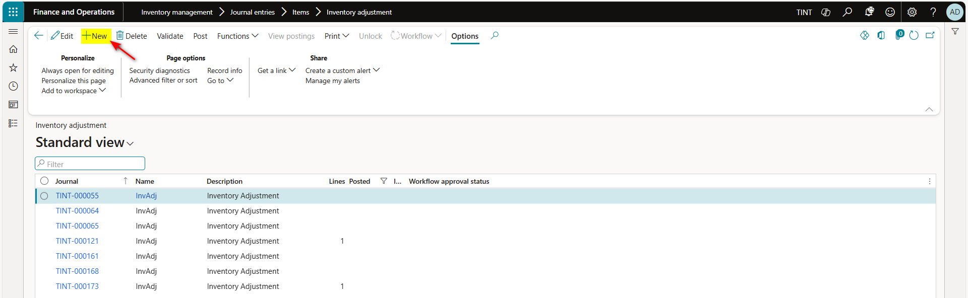

1. In the journal lines Fast tab, click New to create a new journal line.
2. In the Item number field, select the item number.
3. In the Warehouse field, select the warehouse.
4. In the Quantity field, enter the quantity.
5. In the Cost price field, enter the cost price for the item.
6. Click on Post, to post the journal.

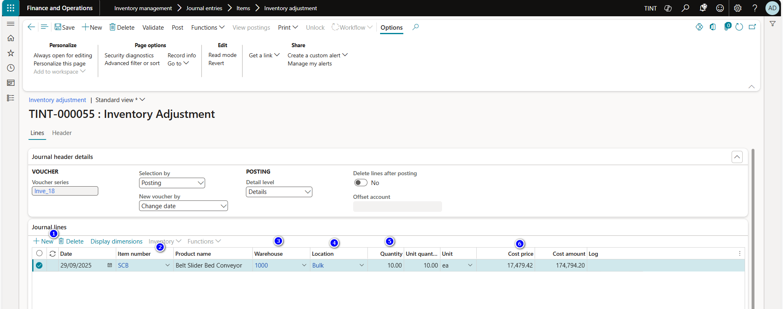

### 3.2.3 Counting journal

* **Counting journals** let you correct the current on-hand inventory that is registered for items or groups of items, and then post the actual physical count, so that you can make the adjustments that are required to reconcile the differences.

1. Navigate to Inventory management > Journal entries > Item counting > Counting

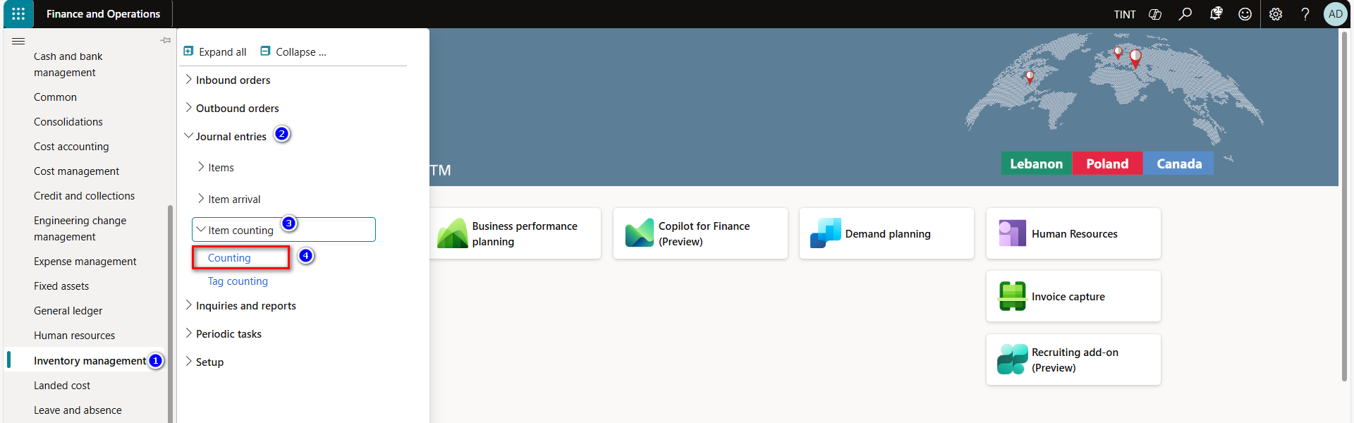

1. Click New, to create new journal.
2. In the action pane, click Create lines and then select On-hand.

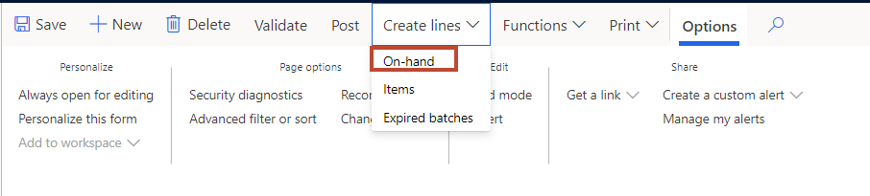

1. In the create on-hand counting journal form, select the counting date, counting group and enter the maximum number of lines.
2. Note: We can add lines using New button or Add products
3. Click Ok, to create the journal lines.

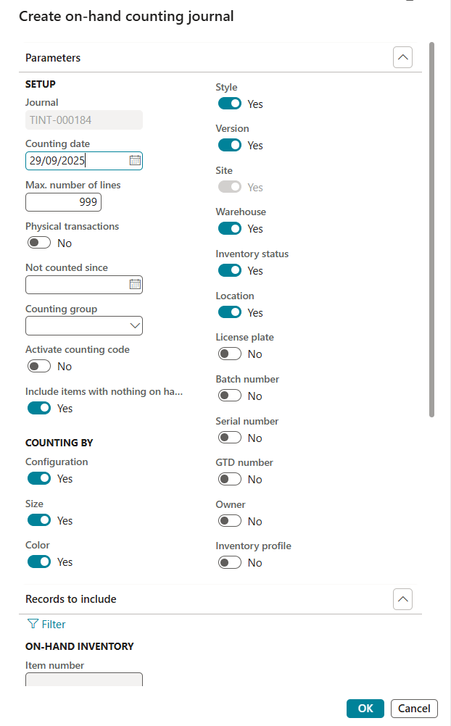

1. In the Counted field, enter the quantity counted when counting the on-hand inventory.
2. In the Quantity field, will show the differences between the system counted and physically counted quantities.
3. Click Post, to post the quantity.

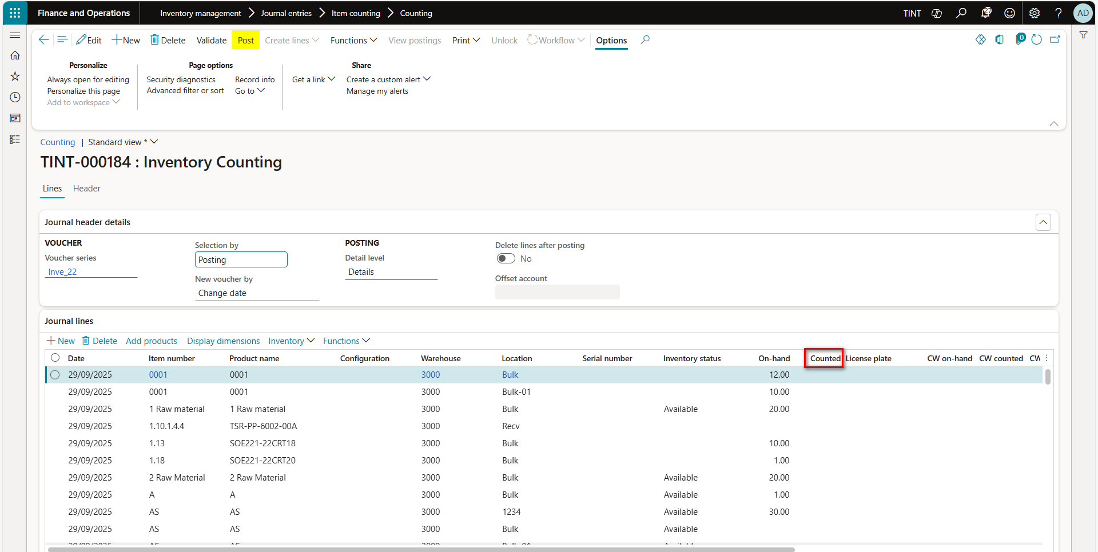

### 3.2.4 BOM journal

A BOM journal will be used for raw material distribution. A BOM journal allows the user to stock out one material and stock in others as-if they are related through a BOM.

For example, if the factory wants a part of a sheet metal, then inventory needs to use existing items (coming from BOM integration) vs the sheet metal and build a BOM for it using a BOM journal

Navigate to Inventory management, Journal entries, Items, Select Bill of Material, open the BOM journal number > New

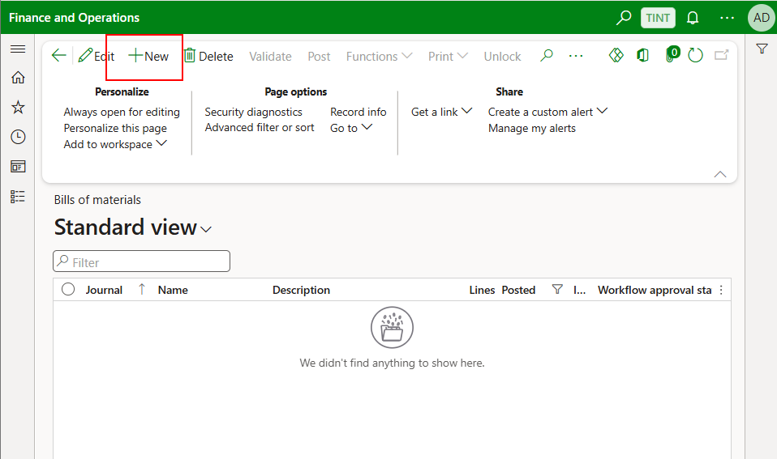

Add the sheet metal with negative quantity (the cost is automatically reflected from the product setup) and the parts to be produced as positive quantity.

Update the cost of the positive quantities as per the usage.

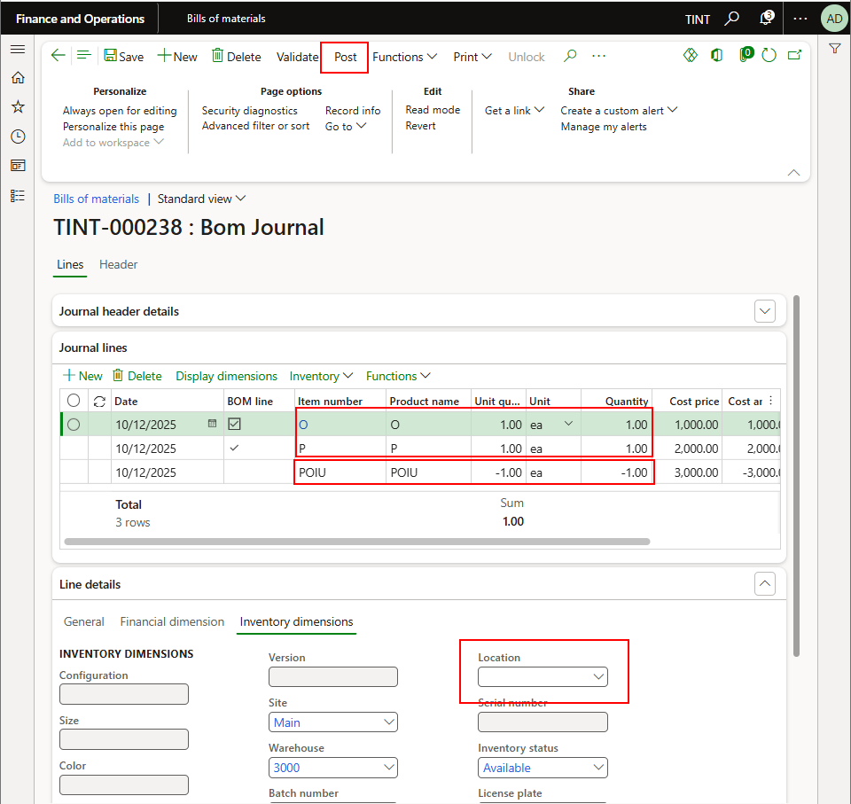

Post the BOM Journal.

### 3.2.5 Transfer journal

* **Use transfer journals** to transfer items between stocking locations, batches, or product variants without associating any cost implications. For example, you can transfer items from one warehouse to another warehouse within the same company. When you use a transfer journal, you must specify both the "from" and "to" inventory dimensions (for example, for Site and Warehouse). The on-hand inventory for the defined inventory dimensions changes accordingly. Inventory transfers reflect the immediate movement of material. In-transit inventory isn't tracked. If you need to track in-transit inventory, use a transfer order instead. When you post a transfer journal, two inventory transactions are created for each journal line:
* An inventory issue at the "from" location.
* An inventory receipt at the "to" location.

1. Navigate to Inventory management > Journal entries > Transfer

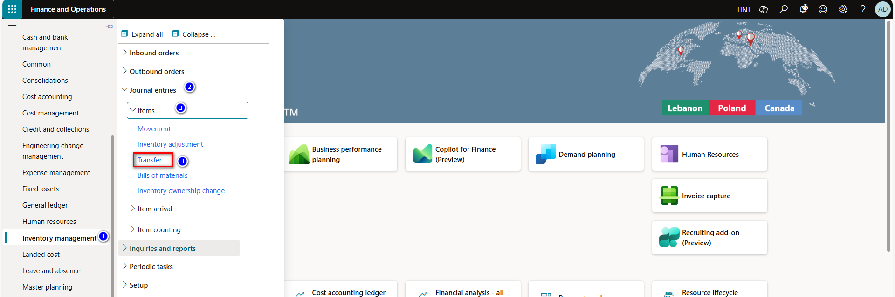

1. Click New, to create new transfer journal.
2. In the journal lines Fast tab, click New to create a new line.
3. Select and specify the Item number and Quantity that would be transfer from warehouse to another.
4. In the from site field, select the site to transfer from.
5. In the to site field, select the site to transfer to.
6. In the from warehouse field, select the warehouse to transfer from.
7. In the to warehouse field, select the warehouse to transfer to.
8. Click on Post, to post the quantity.

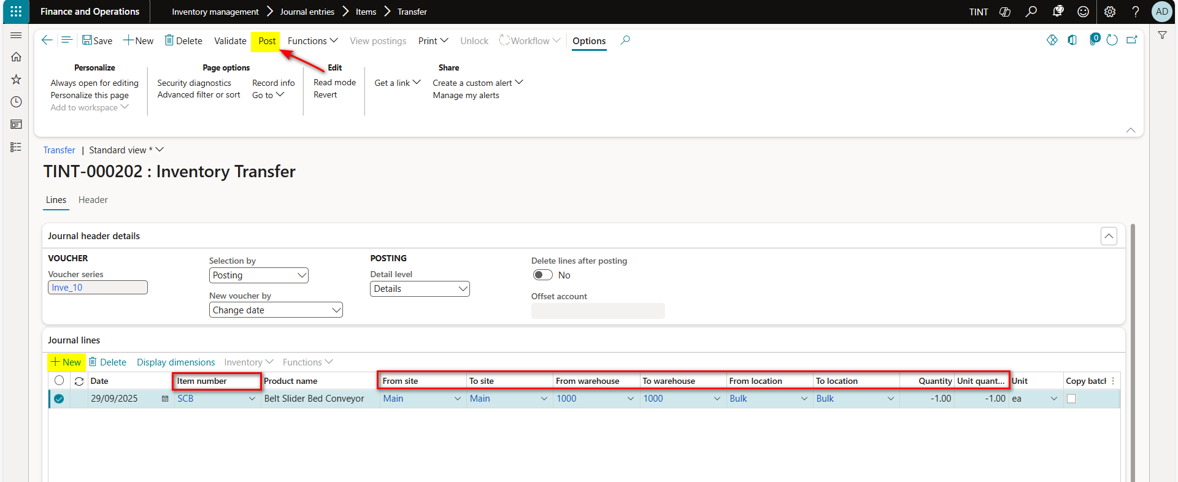

## Production Process (Warehouse work for raw material picking)

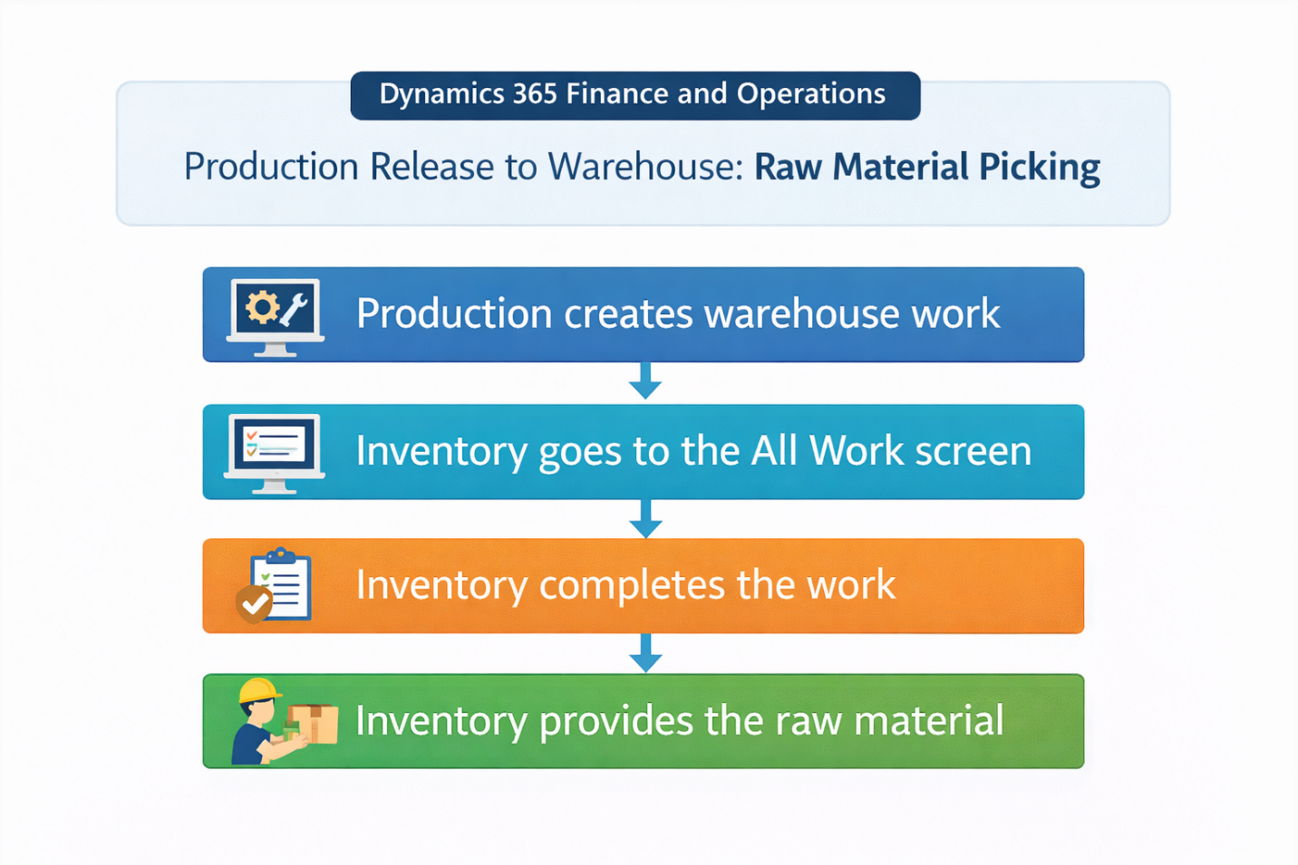

This process is used whenever the warehouse worker wants to provide inventory items to production team.

* **Work for raw material picking** is generated during release production order. Work is generated only for the quantity of materials that was physically reserved for the production order before the order was released. This work is often used for picking the raw materials that are required for production process from raw materials location to factory location.

1. Navigate to warehouse management > work > all work

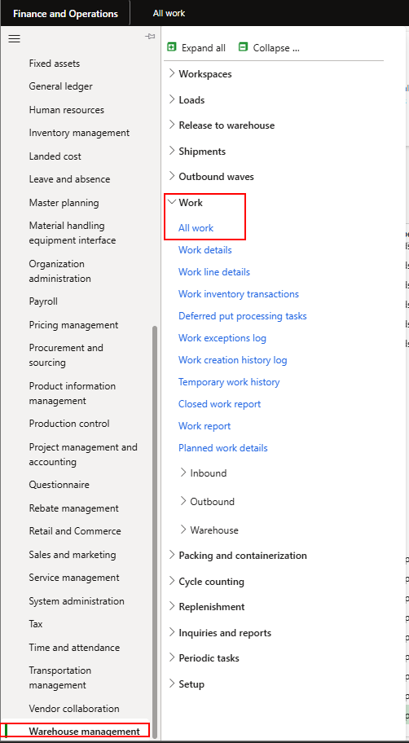

1. On this screen you can see all warehouse work that needs to be completed. You can filter by work order type or by order number for easier navigation.

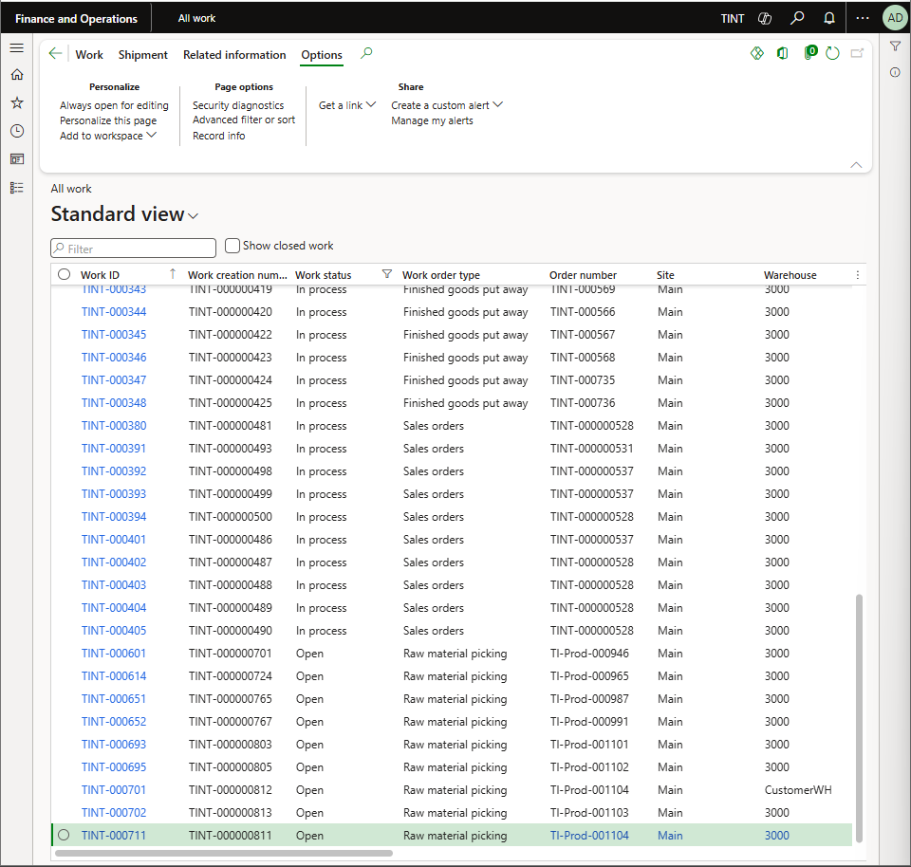

1. Select the work that needs to be completed
2. Complete the work. From Complete work > Select the user ID > Validate the work > Complete work.
3. The work will be closed, and the raw materials will be picked up at the factory location.

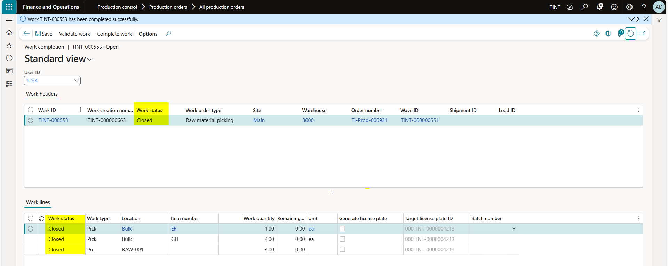

* **Important note: if the user posts the picking list with quantities less than the work quantities and report as finished the production order, the inventory must use transfer journal to transfer the remaining quantities from the factory to raw material location.**

## 3.4 Consume items on the project directly

Project item journal is used to do 2 things: remove the quantity of the item from inventory and record the cost of the item directly on a project.

Navigate project management and accounting > projects > all projects.

* + - * 1. Select the desired project
        2. Under Projects > Journals. Select Item

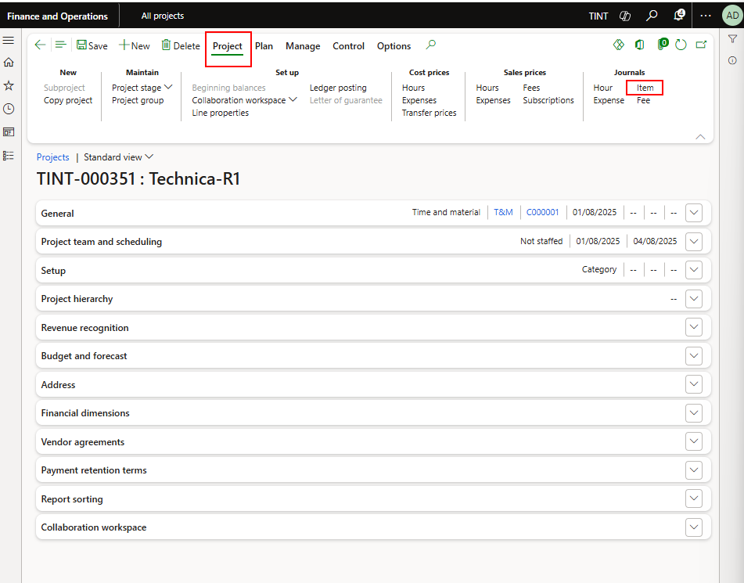

* + - * 1. Select New

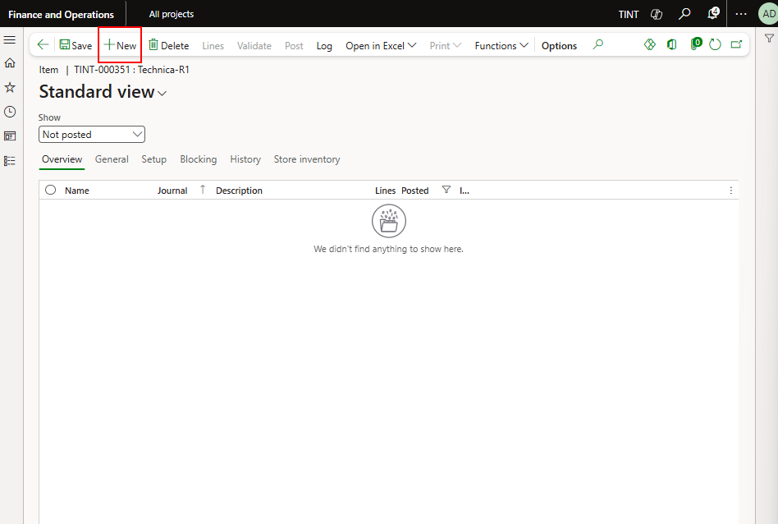

* + - * 1. Select lines

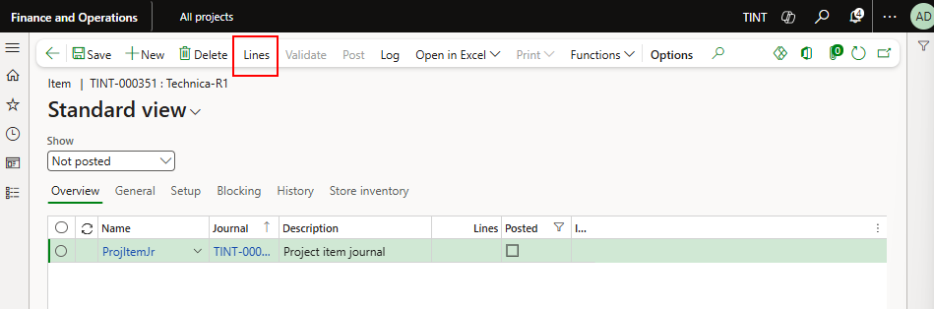

* + - * 1. Add the item and quantity and post the journal

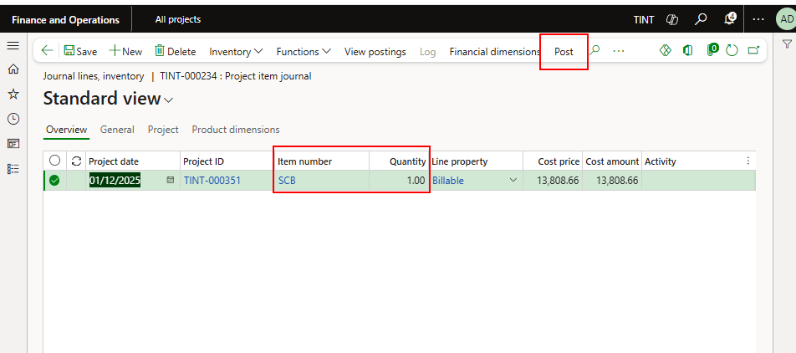

## 3.5 Counting by the warehouse management mobile application

Counting can be done on the warehouse management mobile application. The mobile application should be installed, and it offers more flexibility in the counting process.

1. Sign in to the mobile application
2. Select the counting menu item

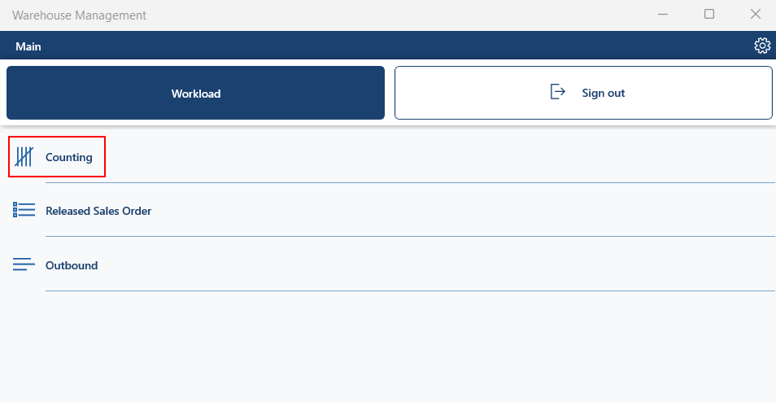

1. Enter the location for the counting

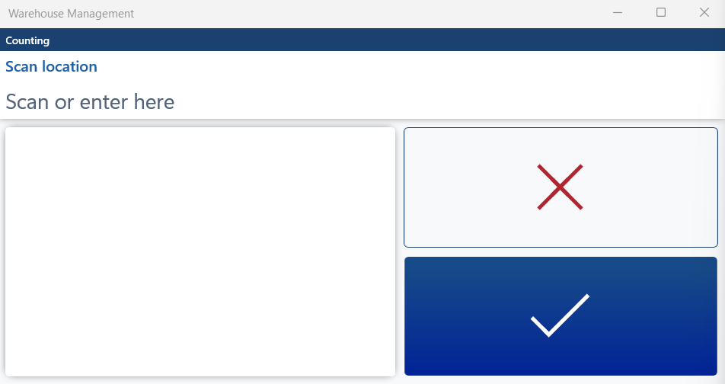

1. Enter item number

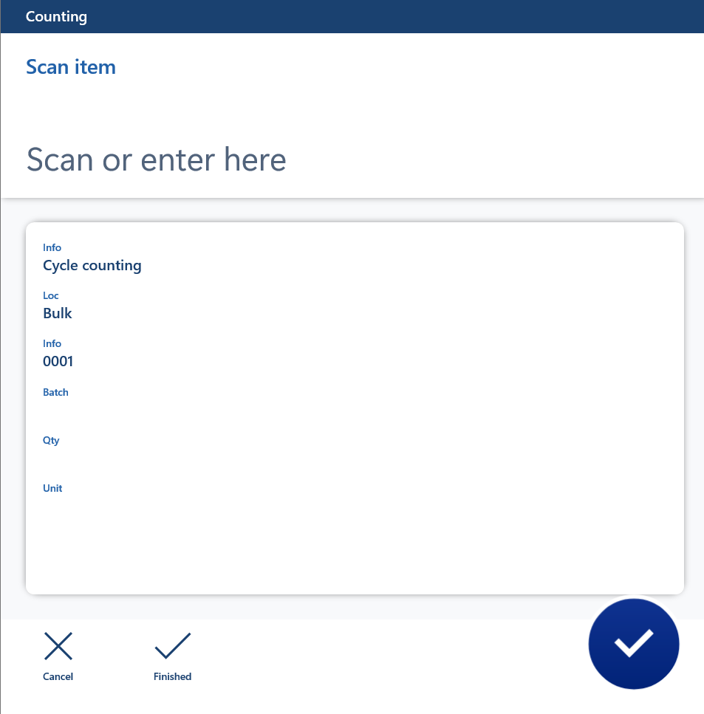

1. Enter the counted quantity

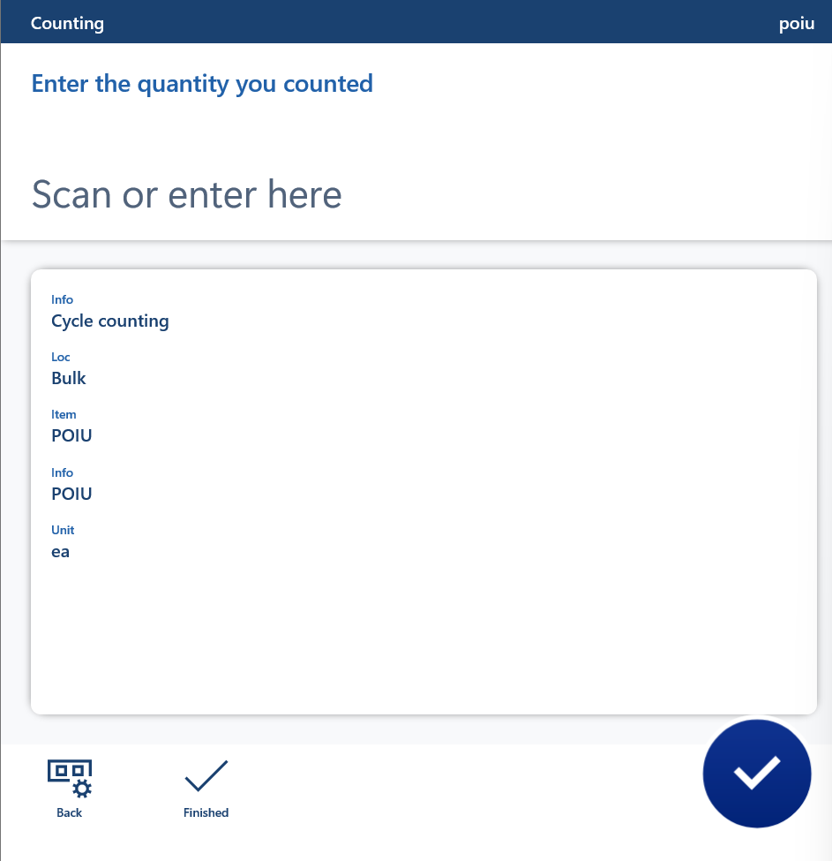

1. When done press finished



1. Repeat the same process for items that you need to count

# 4.0 Master Planning

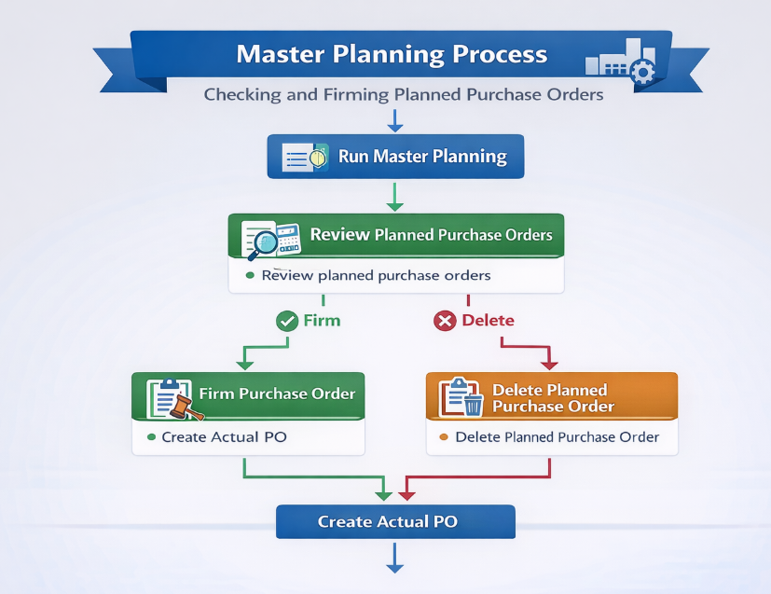

Master planning is a tool in Microsoft Dynamics 365 Finance and Operations that helps organizations in the planning process. Master planning will consider the demand for the item and compare it to the inventory and based on these calculations, planned purchase orders or planned production order are created.

Inventory will run master planning for stock replenishment. Most inventory items are based on the minimum maximum configuration. The minimum maximum configuration for the item compares the inventory of the item with the minimum value specified on the item and if it is less, a planned purchase order will be created to raise inventory up to the maximum. The maximum will also be specified on the item level.

1. There are two types of master plans, one based on the requirement, and the other is for the replenishment of stock based on the minimum and maximum configuration for the item. The inventory clerk/project manager will run master planning. When planned purchase orders are created, they will show under master planning > master planning > planned orders
2. Check the planned orders that are created

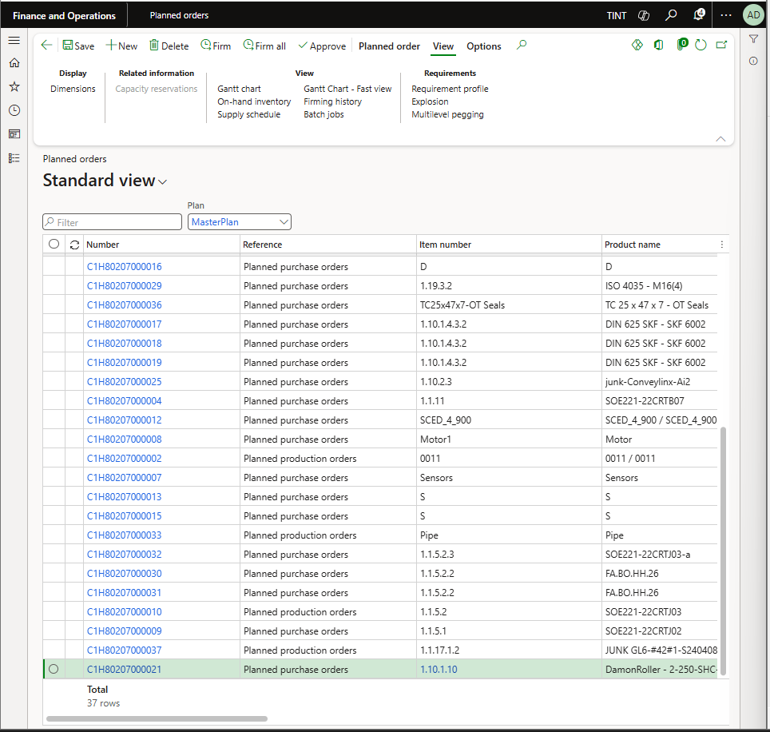

1. In case everything looks fine for the inventory, approve the planned order. In case there is a planned order where there is an alternative available in stock, do not approve the planned order.

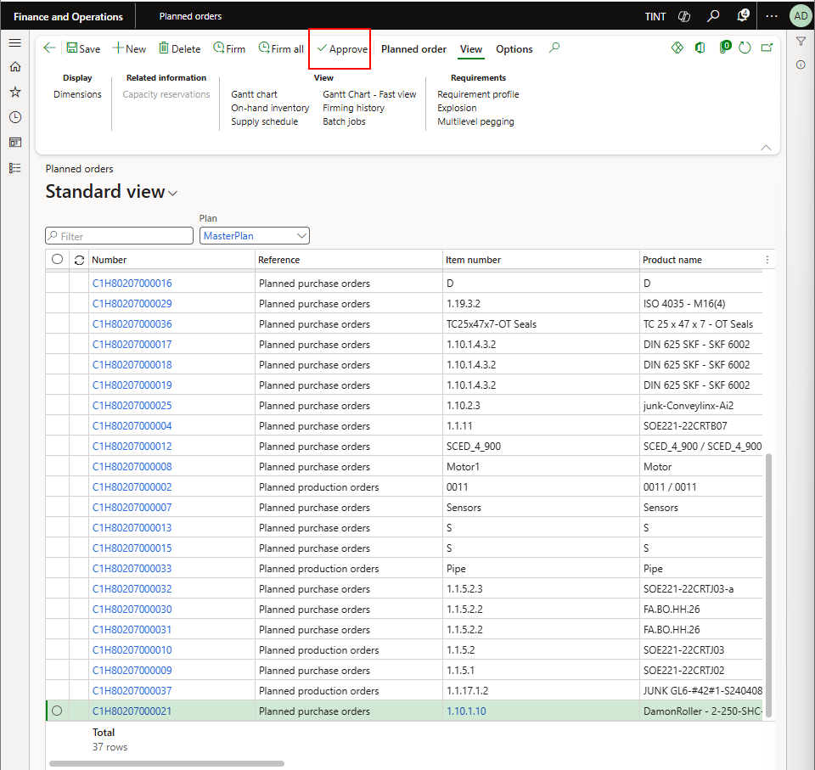

# 5.0 Reserved and unreserved item check

When items are bought for a project or items are reserved on a project, they will show in the below form. Nonetheless it is possible to unreserve the item for it to be available for use

*Inventory management > Inquiries and reports > transactions*

1. All inventory transactions will appear in the grid
2. To check the items reserved for a specific project, filter on the project ID

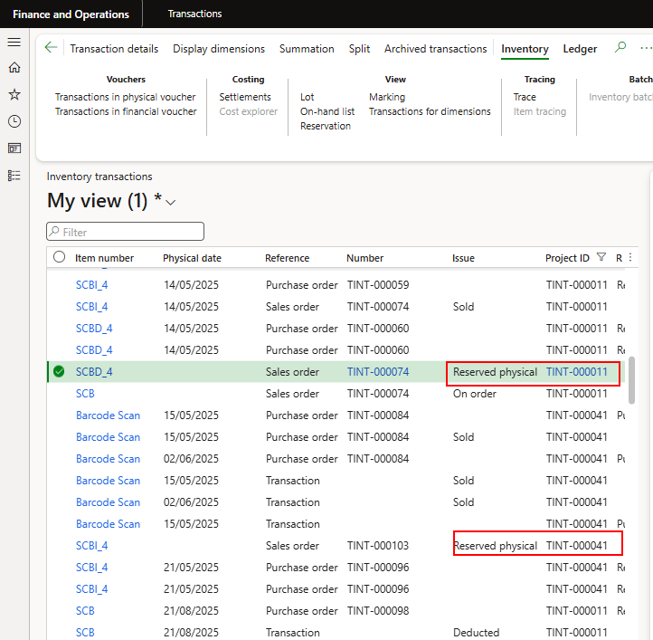

1. To unreserve the item from the project, under inventory > View > select reservation

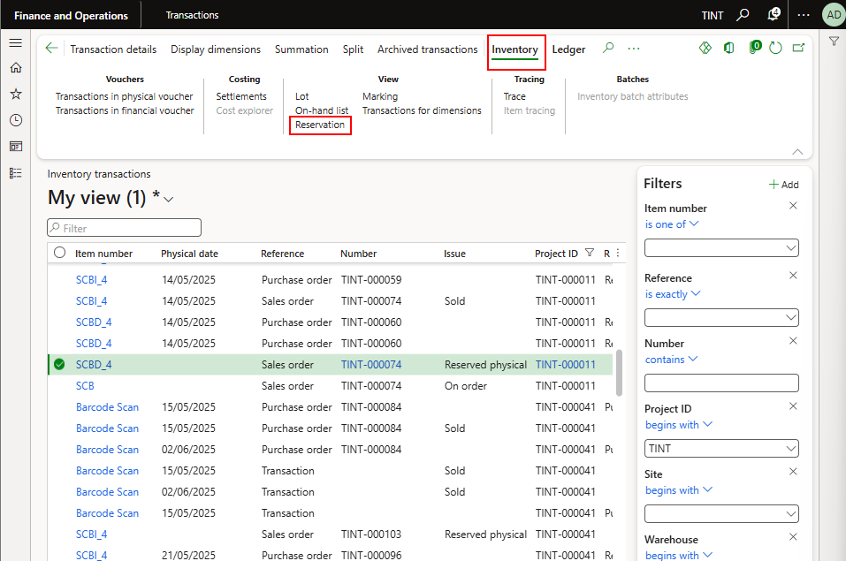

1. Change the reservation to 0 and select reserve lot

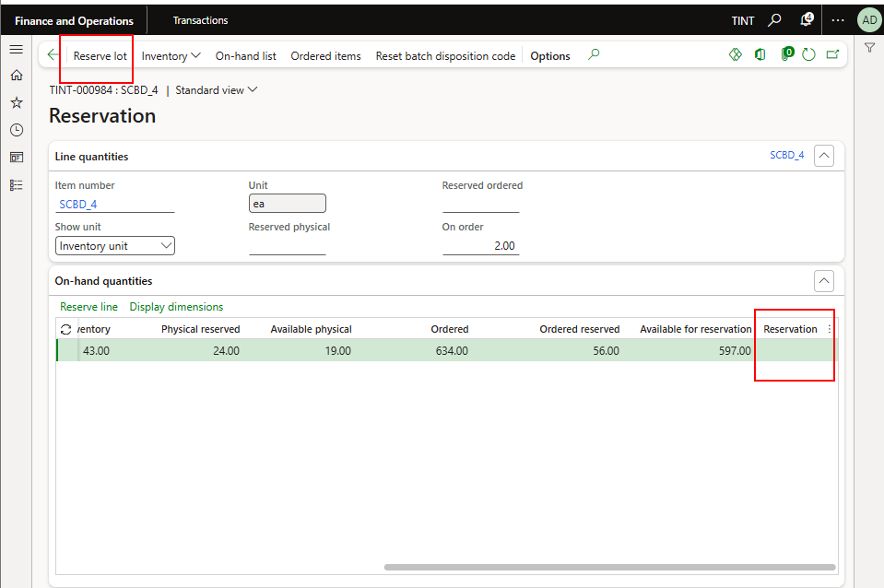

# 6.0 Inventory Reports

## 6.1 On-hand list

On the **On-hand list** page, you can filter by dimension values (product, storage, and/or tracking dimensions) and break down output values by dimension values. The values that are shown on the page change based on the filter and display dimensions that you set. This article shows a few of the ways that the various filtering and output options work together, and how they affect the results that are presented.

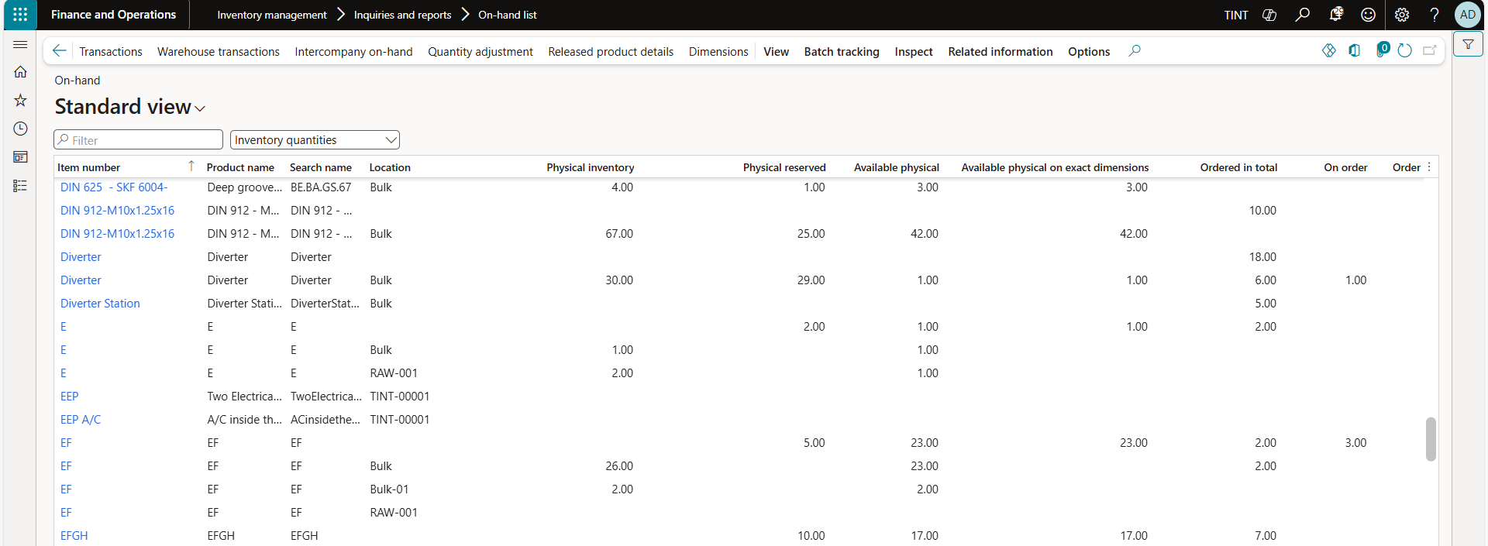

|  |  |
| --- | --- |
| Field | Description |
| Physical inventory | The physical quantity that is available in inventory. |
| Physical reserved | The total quantity that was physically reserved. |
| Available physical | The available (not reserved) quantity that is available in physical inventory.  **Available physical** is a calculated field. The value equals the **Physical inventory** value minus the **Physical reserved** value. |
| Ordered in total | The total quantity that is included on inbound orders or that has a positive quantity in various inventory journals. |
| On order | The total quantity that is included on outbound orders or that has a negative quantity in various inventory journals. |
| Ordered reserved | The total quantity that is reserved on ordered receipts. The value in this field represents the total quantity of items in outbound transactions that have a status of *Ordered reserved*. Items that are reserved as ordered aren't physically available in inventory. Therefore, they can't be directly picked and delivered. |

## 6.2 Inventory transactions

Use the **Transactions details** page to view details of any selected inventory transaction with its reference (Transfer, production line, production, sales order, purchase order), the status for each transaction (Received, deducted, purchased, sold, reserved) and the cost amount for each transaction.

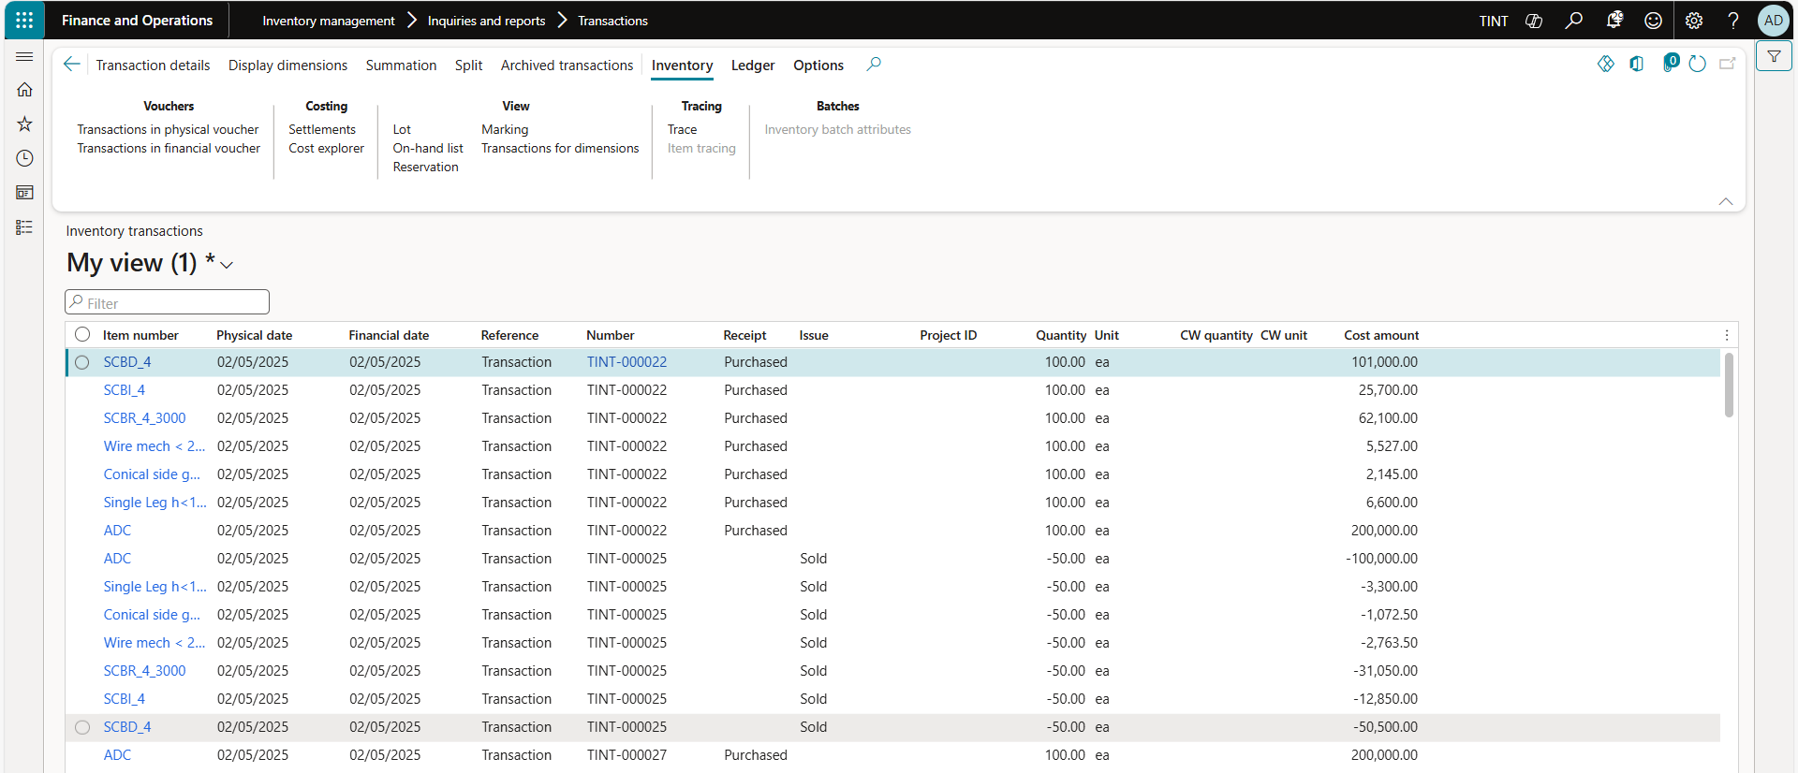

## 6.3 Critical on-hand inventory

**Critical on-hand inventory** identifies items which physical and ordered inventory quantities are below their specified minimum level. This report is essential for proactively managing low-stock situations. Critical on-hand inventory shows physical and ordered inventory that is lower than the minimum that identified in item coverage.

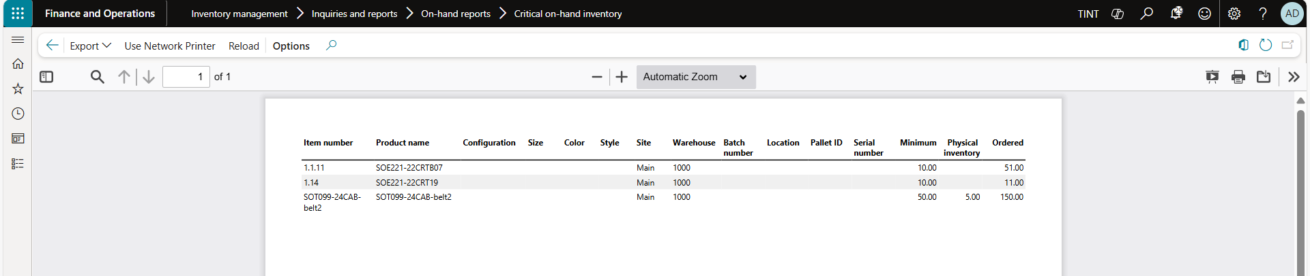

## 6.4 Inventory value report

**Inventory value reports** provide details about your inventory physical and financial quantities and amounts. You can view the reports in many ways. For example, you can show totals or transactions, or filter by items or a time range. You can view cost of goods sold (COGS) values or work in process (WIP) values and set other options.

Inventory value reports let you perform the following tasks:

* + - * 1. Do reconciliation between the general ledger and inventory.
        2. Consult on-hand inventory and values for a specific period.
        3. Create report configurations that are tailored for a specific purpose.
        4. Save report configurations so that they can be used multiple times.
        5. Add ranges to filter data when you run a report.

